Applications in Geometry

1. Parallelogram *ABCD* has vertices *A*(1, 2), *B*(5, 3), *C*(6, 6), and *D*(2, 5). Point *P* lies on $\overline{AD}$ at (1 $\frac{2}{3}$, 4). Point *Q* lies on $\overline{BC}$ such that $\overline{PQ}$ is parallel to .  
     
   A coordinate grid in the first quadrant. The horizontal and vertical axes have scales that go from 0 to 7 in increments of 1/2. Parallelogram ABCD is plotted with vertices A(1, 2), B(5, 3), C(6, 6), and D(2, 5). Point P is plotted on line segment AD at (1 2/3, 4).
     
     
   Write an ordered pair to represent the location of Point *Q*.
2. Line *m* can be represented by the equation 3*x* – 6*y* = 18.  
     
   Write an equation of the line perpendicular to line *m* that passes through the point (–4, 1).
3. What is the slope of a line perpendicular to 2*x* + 3*y* = 6?  
     
   A. $-\frac{3}{2}$  
   B. $-\frac{2}{3}$  
   C. $\frac{2}{3}$  
   D. $\frac{3}{2}$
4. Two water tanks are shown. Tank A is a rectangular prism and Tank B is a cylinder.   
   The tanks are not drawn to scale.  
     
   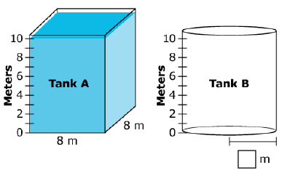  
     
   Tank A is filled with water to the 10-meter mark.  
     
   Half of the water from Tank A is poured into Tank B. The water level on Tank A drops to   
   5 meters and the water level on Tank B becomes 4 meters.  
     
   What is the radius of the base of Tank B, to the nearest meter?
5. The dimensions and a cross section of a rainwater cistern are shown in the figure.  
     
   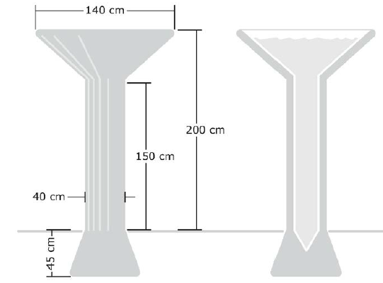  
     
   If you want to, you may use these conversations and formulas:

1 m = 100 cm Volume of a sphere: *V* =   
1 cm = 10 mm Volume of a cylinder: *V* =   
1 cm3 = 1 mL Volume of a cone: *V =*   
1 L = 1000 mL

Estimate the number of liters (L) of water the cistern can hold when full.

1. Eric is using a shovel to clear the snow from his driveway. He moves 8 shovelfuls of snow   
   each minute. After 60 minutes, Eric states, “I think I have shoveled more than a ton of snow.”  
     
   **Part A**  
   Estimate the weight of snow that Eric can move with each shovelful.  
     
   If you want to, you can use the table of weights of everyday objects below.  
   A ton is 2000 pounds, and a pound is 16 ounces.

| **Object** | **Weight** |
| --- | --- |
| Basketball | 20 ounces |
| Apple | 7 ounces |
| Bicycle | 20 pounds |
| Car | 1.5 tons |
| Pack of chewing gum | 1 ounce |

**Part B**Use your estimate to decide if Eric’s claim is correct or not.

1. A researcher models the area of the surface of a pond using a rectangle, a semi-circle, and a right isosceles triangle.  
     
   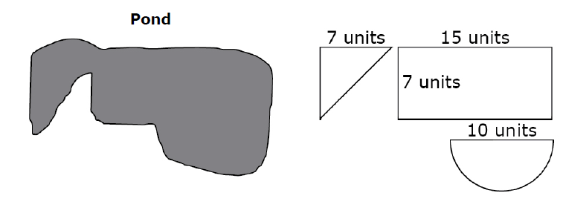  
     
   Explain whether the researcher’s model will estimate an area greater than, equal to, or less than the actual area of the pond’s surface. Use specific information from the pond and/or model and mathematics to support your answer.

**Teacher Material**

G-GMD.A

Explain volume formulas and use them to solve problems

G-MG.A

Apply geometric concepts in modeling situations

G-CO.D

Make geometric constructions

G-GPE.A

Translate between the geometric description and the equation for a conic section

| **Question** | **Claim** | **Key/Suggested Rubric** |
| --- | --- | --- |
| 1[1] | 1 | **1 point:** (5, 5). |
| 21 | 1 | **1 point:** *y* = –2*x* –7, or equivalent equation in any form. |
| 31 | 1 | **1 point:** Selects D. |
| 4[2] | 2 | **1 point:** 5. |
| 5[3] | 4 | **1 point:** An estimate between 340 and 700. |
| 63 | 4 | **2 points:** A reasonable estimate for Part A (1 pound to 15 pounds) AND a decision for Part B that is consistent with the estimate in Part A (an estimate less than 4 $\frac{1}{6}$ pounds results in Eric’s statements not being correct, and estimates of 4 $\frac{1}{6}$ pounds or more results in Eric’s statements being correct).  **1 point:** A reasonable estimate for Part A OR a decision for Part B that is consistent with the estimate in Part A. |
| 73 | 4 | **1 point:** The student determines the model will estimate an area less than the actual area of the pond’s surface and provides mathematical support (e.g., the sections of the pond modeled by each figure are larger than the figures in the model). |

1. Adapted from the Mathematics K–12 Learning Standards. Internet. Available from <http://www.k12.wa.us/Mathematics/Standards.aspx>; accessed 11/2015.
2. Adapted from Smarterbalanced.org. Grades 11, Claim 2 Item Specifications. Internet. Available from <http://www.smarterbalanced.org/smarter-balanced-assessments/>; accessed 11/2015.
3. Adapted from Smarterbalanced.org. Grades 11, Claim 4 Item Specifications. Internet. Available from <http://www.smarterbalanced.org/smarter-balanced-assessments/>; accessed 11/2015.