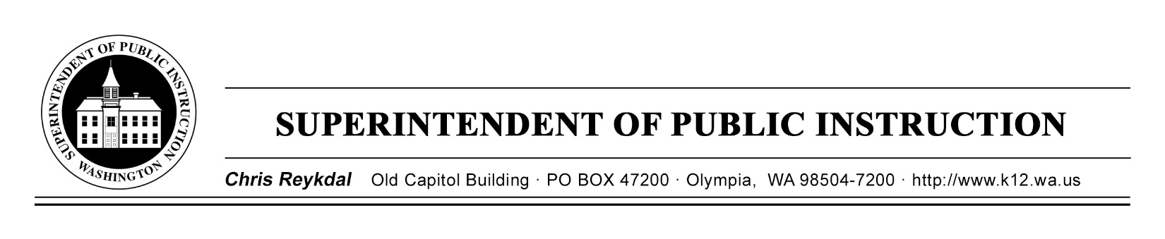
Dyslexia Advisory Council | September 25, 2018 | Sea -Tac Conference Center
E2SSB 6162

Time | Focus | Resources | Notes
8AM | Coffee and Sign In
8:30 AM | Welcome
 | Extended Learning Time Reflection
Ah Ah’s
Goals for the Day
 | Literacy Skills Identified in Statute | E2SSB 6162 (B)
10:30 AM | Break
 | WA State Assessment System | State Assessment Definitions-Handout
11:45 AM | Working Lunch-Travel Reimbursements
 | When Do We Screen?
 | Choosing Screeners and the RFI Process
Messaging to the Public
Extended Learning for November
Next Steps
3 PM | Good Bye and Safe Travels

