

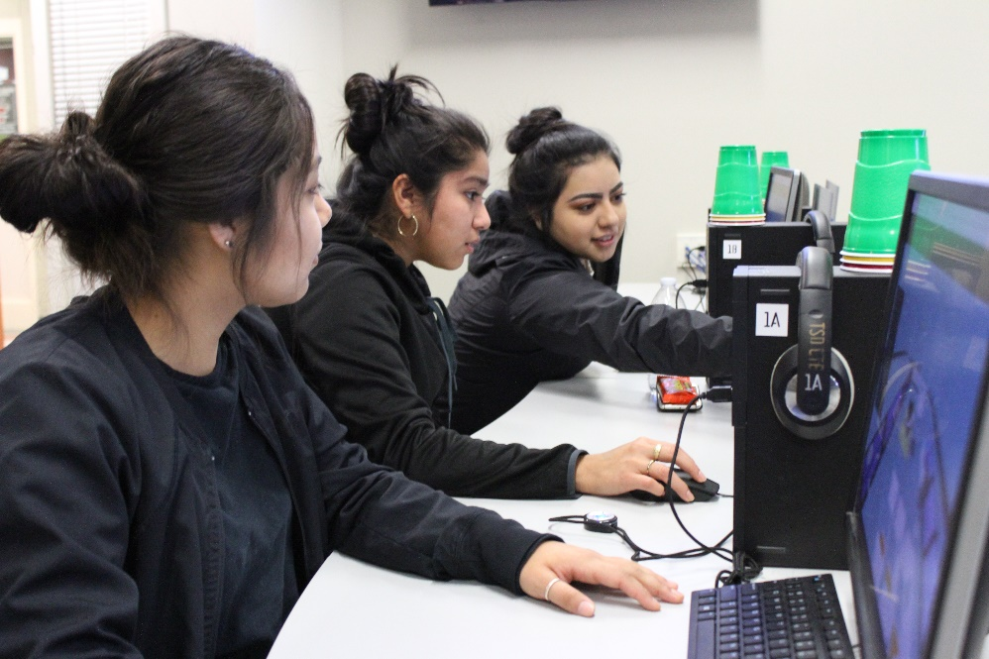**Educational Technology Learning Standards: Grades 3-5**

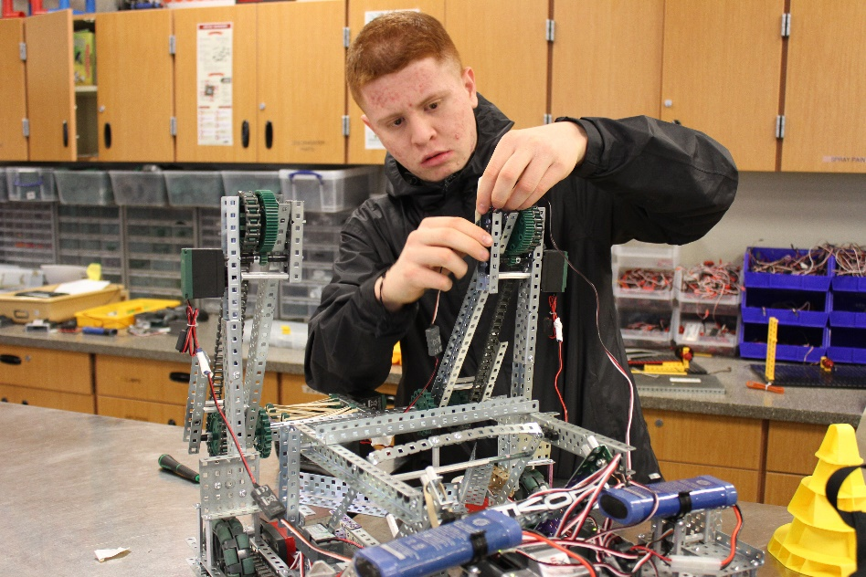

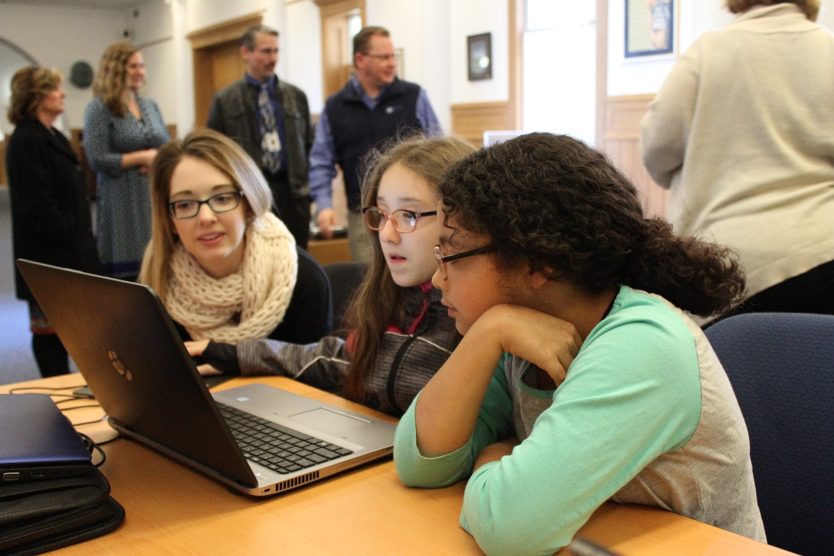

***Adopted May, 2018***

*****Photos: Toppenish High School, Sunnyside High School and OSPI, courtesy of OSPI***

# For complete K-12 Educational Technology Standards go to:

[*http://www.k12.wa.us/EdTech/Standards/default.aspx*](http://www.k12.wa.us/EdTech/Standards/default.aspx)

**Creative Commons Attribution-NonCommercial LIcense Logo (CC BY NC)
**

Except where otherwise noted, the Washington Educational Technology K–12 Learning Standards (<http://www.k12.wa.us/edtech/Standards>) by the Office of Superintendent of Public Instruction (<http://k12.wa.us/>) are licensed under a Creative Commons Attribution Non-Commercial 4.0 International License (<https://creativecommons.org/licenses/by-nc/4.0/>). All logos and trademarks are property of their respective owners.

Portions of this work are based on the 2016 International Society for Technology in Education (ISTE) Standards for Students (<https://www.iste.org/standards/for-students>)

ISTE Standards for Students, ©2016, ISTE (International Society for Technology in Education), iste.org. All rights reserved.

Standards referenced include:

*The College, Career, and Civic Life (C3) Framework for Social Studies State Standards: Guidance for Enhancing the Rigor of K-12 Civics, Economics, Geography, and History.* National Council for the Social Studies (NCSS),Silver Spring, MD, 2013, <https://www.socialstudies.org/c3>

*Common Core State Standards.* National Governors Association Center for Best Practices and Council of Chief State School Officers, Washington D.C., 2010, <http://www.corestandards.org>

*CSTA K-12 Computer Science Standards.* Computer Science Teachers Association*,* Albany, NY, 2017, <http://www.csteachers.org/page/standards>

Next Generation Science Standards: For States, By States.The National Academies Press, Washington D.C., 2013, <https://www.nextgenscience.org>

# 

# 2018 Standards for Technology Literate & Fluent Students

***(Based upon 2016 ISTE Student Standards)***

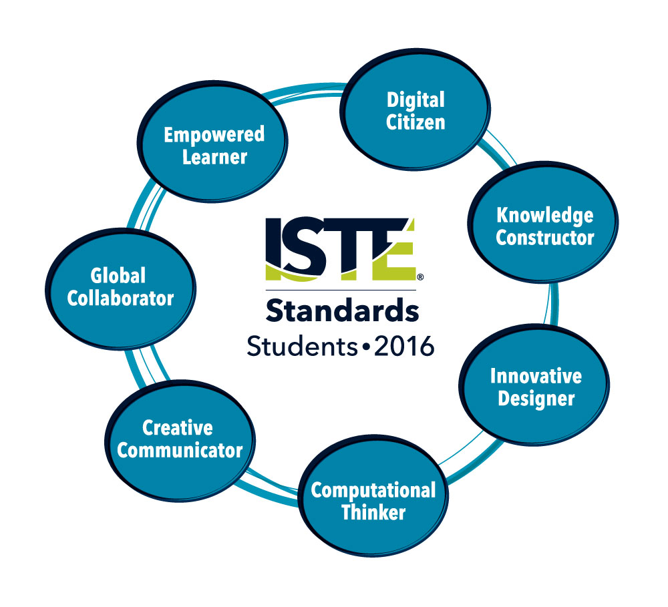

1. **Empowered Learner** - Students leverage technology to take an active role in choosing, achieving and demonstrating competency in their learning goals, informed by the learning sciences.

2. **Digital Citizen** - Students recognize the rights, responsibilities and opportunities of living, learning and working in an interconnected digital world, and they act and model in ways that are safe, legal and ethical.

3. **Knowledge Constructor** - Students critically curate a variety of resources using digital tools to construct knowledge, produce creative artifacts and make meaningful learning experiences for themselves and others.

4. **Innovative Designer** - Students use a variety of technologies within a design process to identify and solve problems by creating new, useful or imaginative solutions.

5. **Computational Thinker** - Students develop and employ strategies for understanding and solving problems in ways that leverage the power of technological methods to develop and test solutions.

6. **Creative Communicator** - Students communicate clearly and express themselves creatively for a variety of purposes using the platforms, tools, styles, formats and digital media appropriate to their goals.

7. **Global Collaborator** - Students use digital tools to broaden their perspectives and enrich their learning by collaborating with others and working effectively in teams locally and globally.

ISTE Standards•S © 2016 International Society for Technology in Education.

# Understanding the Educational Technology Standards Framework

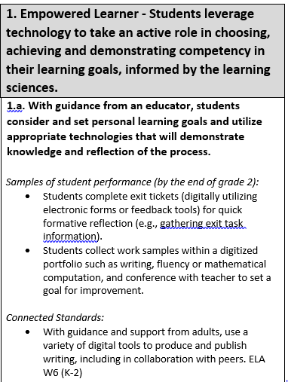

A **Standard**is a broad statement of the learning that applies to Grades K–12.

A **Performance Indicator** is a statement containing the essential content or process to be learned and the cognitive demand required to learn it. Each standard includes developmentally-appropriate grade-band performance indicators, which are considered essential to the standards.

**Samples of student performance** provide specific illustrations of the learning by the completion of the grade band. However, these examples are not exhaustive, and educators are encouraged to find multiple ways by which learners can demonstrate what they know.

**Connected standards** are logical connections to other content areas at approximately the same grade that also have a match in cognitive demand. With this alignment, teachers can expect that when students can demonstrate mastery of one standard (educational technology or other content area), they can also meet the other.

**Connected Standards Codes**

* C3= College, Career, and Civic Life (C3) Framework for Social Studies State Standards (<https://www.socialstudies.org/c3>)
* CS=Computer Science Learning Standards (<http://www.k12.wa.us/ComputerScience/>)
* H=Health Standards (<http://www.k12.wa.us/HealthFitness/Standards.aspx>)
* ELA=English Language Arts Standards (<http://www.corestandards.org/ELA-Literacy/>)
* Math=Mathematics Standards (<http://www.k12.wa.us/Mathematics/Standards.aspx>)
* PE=Physical Education Standards (<http://www.k12.wa.us/HealthFitness/Standards.aspx>)
* Science=Next-Generation Science Standards (<https://www.nextgenscience.org/get-to-know>)
* Social Studies=Social Studies Standards (<http://www.k12.wa.us/SocialStudies/EALRs-GLEs.aspx>)

# Grades 3-5 Standards for Technology Literate and Fluent Students

|  |  |
| --- | --- |
| **1. Empowered Learner - Students leverage technology to take an active role in choosing, achieving and demonstrating competency in their learning goals, informed by the learning sciences.** | |
| **1.a. Students develop learning goals in collaboration with an educator, select the technology tools to achieve them, and reflect on and revise the learning process as needed to achieve goals.**  *Samples of student performance (by the end of grade 5):*   * Students monitor their reading fluency using a technology-assisted program (e.g., fluency tutor) or audio recordings, and set goals for improvement. * Students record each other doing a specific task in P.E., then review the video and rate themselves on a rubric before making a goal to improve. * With guidance, students identify and use digital learning tools or resources to support planning, implementing and reflecting upon a defined task. * Students explain their choice of selected digital learning tools and resources to support productivity and learning. * Students seek information about appropriate technology to use in a cultural setting and abide by the cultural norms established. |
| **1.b. With the oversight and support of an educator, students build a network of experts and peers within school policy and customize their environments to enhance their learning.**  *Samples of student performance (by the end of grade 5):*   * Students create a list of classmates to ask for help based on skills, and keeps this list to use later. |

|  |
| --- |
| **1.c. Students seek feedback from both people and features embedded in digital tools, and use age-appropriate technology to share learning.**  *Samples of student performance (by the end of grade 5):*   * Students evaluate the various features of digital learning tools and select tools based on the characteristics of a specific audience. * Students create a digital piece of writing or presentation and use collaborative digital tools to solicit teacher and peer feedback to help make edits, as appropriate (e.g., spell and grammar check).   *Connected Standards:*   * Add audio recording and visual displays to presentations when appropriate to enhance the development of main ideas and themes. ELA SL 4.5 * With some guidance and support from adults, use technology, including the Internet, to produce and publish writing as well as to interact and collaborate with others. ELA W 4.6 |
| **1.d. Students explore age-appropriate technologies and begin to transfer their learning to different tools or learning environments.**  *Samples of student performance (by the end of grade 5):*   * Students collect and evaluate data, and create graphical displays using the technology tool of their choice.   *Connected Standards:*   * Recall information from experiences or gather information from print and digital sources; take brief notes on sources and sort evidence into provided categories. ELA W8 (3) * Recall relevant information from experiences or gather relevant information from print and digital sources; summarize or paraphrase information in notes and finished work, and provide a list of sources. ELA W8 (5) * Model how computer hardware and software work together as a system to accomplish tasks. [CS 1B-CS-02](https://sites.google.com/site/cstastandards/standards) * Determine potential solutions to solve simple hardware and software problems using common troubleshooting strategies. CS 1B-CS-03 |

|  |  |
| --- | --- |
| **2: Digital Citizen - Students recognize the rights, responsibilities and opportunities of living, learning and working in an interconnected digital world, and they act and model in ways that are safe, legal and ethical.** | |
| **2.a. Students demonstrate an understanding of the role an online identity plays in the digital world and learn the permanence of their decisions when interacting online.**  *Samples of student performance (by the end of grade 5):*   * Students can identify the components of digital identities and digital footprints. |
| **2.b. Students practice and encourage others in safe, legal and ethical behavior when using technology and interacting online, with guidance from an educator.**  *Samples of student performance (by the end of grade 5):*   * Students demonstrate appropriate use of technology and explain the importance of responsible and ethical technology use. * Students exercise digital etiquette when communicating and collaborating. * Students identify and discuss laws and rules that apply to digital content and information (e.g., copyright laws).   *Connected Standards:*   * Describe how family, school, community, peers, media, and technology influence food and beverage choices and eating behaviors. H2.N6.4 |

|  |
| --- |
| **2.c. Students learn about, demonstrate and encourage respect for intellectual property with both print and digital media when using and sharing the work of others.**  *Samples of student performance (by the end of grade 5):*   * Students explain basic concepts of plagiarism and copyright. * Students use digital citation tools to cite sources with appropriate guidance.   *Connected Standards:*   * Recall relevant information from experiences or gather relevant information from print and digital sources; summarize or paraphrase information in notes and finished work, and provide a list of sources. ELA W8 (5) * Observe intellectual property rights and give appropriate attribution when creating or remixing programs. CS 1B-AP-14 * Use public domain or creative commons media, and refrain from copying or using material created by others without permission. CS 1B-IC-21 |
| **2.d. Students demonstrate an understanding of what personal data is, how to keep it private and how it might be shared online.**  *Samples of student performance (by the end of grade 5):*   * Students demonstrate understanding of different levels of security when using personal information and passwords.   *Connected Standards:*   * Discuss real-world cybersecurity problems and how personal information should be protected, such as the necessity of backing up data to guard against loss, how to create strong passwords and the importance of not sharing passwords, or why we should install and keep anti-virus software updated to protect data and systems. CS 1B-NI-05 |

|  |  |
| --- | --- |
| **3. Knowledge Constructor - Students critically curate a variety of resources using digital tools to construct knowledge, produce creative artifacts and make meaningful learning experiences for themselves and others.** | |
| **3.a. Students collaborate with a teacher to employ appropriate research techniques to locate digital resources that will help them in their learning process.**  *Samples of student performance (by the end of grade 5):*   * Students use digital tools to identify questions related to a topic of interest to broaden or narrow the topic as needed. * Students use a variety of appropriate search techniques to locate needed information using digital learning tools and resources. * Students gather, organize and summarize information from multiple digital learning tools and resources to build knowledge of a topic.   *Connected Standards:*   * Draw on information from multiple print or digital sources, demonstrating the ability to locate an answer to a question quickly or to solve a problem efficiently. ELA RI7 (5) * Consult reference materials (e.g., dictionaries, glossaries, thesauruses), both print and digital, to find the pronunciation and determine or clarify the precise meaning of keywords and phrases. ELA L4c (5) |
| **3.b. Students learn how to evaluate sources for accuracy, perspective, credibility and relevance.**  *Samples of student performance (by the end of grade 5):*   * With guidance, students use multiple criteria to differentiate between relevant and irrelevant information found with digital learning tools and resources.   *Connected Standards:*   * Analyze how visual and multimedia elements contribute to the meaning, tone, or beauty of a text (e.g., graphic novel, multimedia presentation of fiction, folktale, myth, poem). ELA RL7 (5) * Describe how family, school, community, peers, media, and technology influence food and beverage choices and eating behaviors. H2.N6 (4) * Evaluates the accuracy of primary and secondary sources. Social Studies 5.1.2 (4) |

|  |
| --- |
| **3.c. Using a variety of strategies, students organize information and make meaningful connections between resources.**  *Samples of student performance (by the end of grade 5):*   * Students interpret and analyze images, diagrams, maps, graphs, infographics, videos, animations, etc. in digital learning tools and resources to clarify and add to knowledge. * Students use digital tools to analyze observations and data collected to determine if patterns are present.   *Connected Standards:*   * Recall relevant information from experiences or gather relevant information from print and digital sources; summarize or paraphrase information in notes and finished work, and provide a list of sources. ELA W8 (5) |
| **3.d. Students explore real world problems and issues and collaborate with others to find answers or solutions.**  *Samples of student performance (by the end of grade 5):*   * Students work collaboratively using technology to identify and analyze a solution to a problem.   *Connected Standards:*   * Using technology, including the internet, to produce and publish writing and to interact and collaborate with others. ELA W6 (3-5) * Identify how peers, media, and technology influence decisions related to tobacco, alcohol, and marijuana. H2.Su1 (4) * Describe influence of peers and social media on body image. H2.So2.5 |

|  |  |
| --- | --- |
| **4. Innovative Designer - Students use a variety of technologies within a design process to identify and solve problems by creating new, useful or imaginative solutions.** | |
| **4.a. Students explore and practice how a design process works to generate ideas, consider solutions, plan to solve a problem or create innovative products that are shared with others.**  *Samples of student performance (by the end of grade 5):*   * Students demonstrate how applying human knowledge using tools and machines extends human capabilities to meet our needs and wants. * Students give examples of how requirements for a product can limit the design possibilities for that product. * Students plan and implement a design process: identify a problem, think about ways to solve the problem, develop possible solutions, test and evaluate solution(s), present a possible solution, and redesign to improve the possible solution. * Students design a digital product with multiple components and describe how the components interact to form a system.   *Connected Standards:*   * Develop a diagram or simple physical prototype to convey a proposed object, tool, or process. Science SEP 2 (3-5) * Use a model to test cause and effect relationships or interactions concerning the functioning of a natural or designed system. Science SEP 2 (3-5) * Analyze and interpret data to make sense of phenomena, using logical reasoning, mathematics, and/or computation. Science SEP 4 (3-5) * Create and/or use graphs and/or charts generated from simple algorithms to compare alternative solutions to an engineering problem. Science SEP 5 (3-5) * Generate and compare multiple solutions to a problem based on how well they meet the criteria and constraints of the design solution. Science SEP 6 (3-5) * Gather relevant information from multiple sources while using the origin, structure, and context to guide the selection. C3 D3.1 (3-5) * Use distinctions among fact and opinion to determine the credibility of multiple sources. C3 D3.2 (3-5) * Construct arguments using claims and evidence from multiple sources. C3 D4.1 (3-5) |
| **4.b. Students use digital and non-digital tools to plan and manage a design process.**  *Samples of student performance (by the end of grade 5):*   * Students generate ideas for a variety of projects (e.g., book talks, informational video, narrative story) using digital storyboard tools. * Students generate ideas using digital mind-mapping tools.   *Connected Standards:*   * Present a summary of arguments and explanations to others outside the classroom using print and oral technologies and digital technologies. C3 D4.3 (3-5) |
| **4.c. Students engage in a cyclical design process to develop prototypes and reflect on the role that trial and error plays*.***  *Samples of student performance (by the end of grade 5):*   * Students generate, develop and communicate design ideas and decisions using appropriate terms and graphical representations.   *Connected Standards:*   * Plan and carry out fair tests in which variables are controlled and failure points are considered to identify aspects of a model or prototype that can be improved. NGSS 3-5-ETS1-3 |
| **4.d. Students demonstrate perseverance when working with open-ended problems.**  *Samples of student performance (by the end of grade 5):*   * Students are given an engineering design challenge, with an end goal in mind, and work through the process collaboratively using digital tools to simulate, record, reiterate, or present solutions. |

|  |  |
| --- | --- |
| **5. Computational Thinker - Students develop and employ strategies for understanding and solving problems in ways that leverage the power of technological methods to develop and test solutions.** | |
| **5.a. Students explore or solve problems by selecting technology for data analysis, modeling and algorithmic thinking, with guidance from an educator.**  *Samples of student performance (by the end of grade 5):*   * Using digital tools, students compare data to create visually appropriate graphical representation of the data (e.g., line graphs, circle graphs, bar graphs, etc.).   *Connected Standards:*   * Compare and refine multiple algorithms for the same task and determine which is the most appropriate. CS 1B-AP-08 * Decide if qualitative or quantitative data are best to determine whether a proposed object or tool meets criteria for success. Science SEP 5 |
| **5.b. Students select effective technology to represent data.**  *Samples of student performance (by the end of grade 5):*   * With guidance, students select media formats appropriate to content and audience.   *Connected Standards:*   * Recall relevant information from experiences or gather relevant information from print and digital sources; summarize or paraphrase information in notes and finished work, and provide a list of sources. ELA W8 (5) * Draw on information from multiple print or digital sources, demonstrating the ability to locate an answer to a question quickly or to solve a problem efficiently. CC ELA RI7 (5) * Organize and present collected data visually to highlight relationships and support a claim. CS 1B-DA-06 * Use data to highlight or propose cause-and-effect relationships, predict outcomes, or communicate an idea. CS 1B-DA-07 |

|  |
| --- |
| **5.c. Students break down problems into smaller parts, identify key information and propose solutions.**  *Samples of student performance (by the end of grade 5):*   * Students create and test solutions to a given problem through the use of a coding activity.   *Connected Standards:*   * Model how information is broken down into smaller pieces, transmitted as packets through multiple devices over networks and the Internet, and reassembled at the destination. CS 1B-NI-04 * Decompose (break down) problems into smaller, manageable subproblems to facilitate the program development process. CS 1B-AP-11 |
| **5.d. Students understand and explore basic concepts related to automation, patterns and algorithmic thinking.**  *Samples of student performance (by the end of grade 5):*   * Students describe a process as a series of actions and how it is used to produce a result, and explain how controls use information to cause systems to change, like a home thermostat turning on the heat based on the low temperature of a room. |

|  |  |
| --- | --- |
| **6. Creative Communicator** - **Students communicate clearly and express themselves creatively for a variety of purposes using the platforms, tools, styles, formats and digital media appropriate to their goals.** | |
| **6.a. Students recognize and utilize the features and functions of a variety of creation or communication tools*.***  *Samples of student performance (by the end of grade 5):*   * Students choose from a variety of digital tools to create a digital "storybook" featuring a narrative, expository, or other piece of writing.   *Connected Standards:*   * Include multimedia components (e.g., graphics, sound) and visual displays in presentations when appropriate to enhance the development of main ideas or themes. ELA SL5 (5) * Create engaging audio recordings of stories or poems that demonstrate fluid reading at an understandable pace; add visual displays when appropriate to emphasize or enhance certain facts or details. ELA SL5 (3) * Present a summary of arguments and explanations to others outside the classroom using print and oral technologies and digital technologies. C3 D4.3 (3-5) * Construct explanations using reasoning, correct sequence, examples, and details with relevant information and data. C3 D4.2 (3-5) |
| **6.b. Students create original works and learn strategies for remixing or repurposing to create new artifacts.**  *Samples of student performance (by the end of grade 5):*   * Students create artifacts using digital learning tools and resources to demonstrate knowledge.   *Connected Standards:*   * Summarize a written text read aloud or information presented in diverse media and formats, including visually, quantitatively, and orally. [ELA](http://www.corestandards.org/ELA-Literacy/SL/5/2/) SL2 (5) * Modify, remix, or incorporate portions of an existing program into one's own work, to develop something new or add more advanced features. CS 1B-AP-12 * Present a summary of arguments and explanations to others outside the classroom using print and oral technologies and digital technologies. C3 D4.3 (3-5) |
| **6.c. Students create digital artifacts to communicate ideas visually and graphically.**  *Samples of student performance (by the end of grade 5):*   * Students use digital tools to create an infographic, flowchart, timeline, or digital museum. * Students create multimedia presentations explaining a hypothesis for a scientific question. * Students create digital presentations that explain the causes(s) and effect(s) of a historical event.   *Connected Standards:*   * Introduce a topic clearly, provide a general observation and focus, and group related information logically; include formatting (e.g., headings), illustrations, and multimedia when useful to aiding comprehension. ELA W.5.2.A * Present a summary of arguments and explanations to others outside the classroom using print and oral technologies and digital technologies. C3 D4.3 (3-5) * Construct maps and other graphic representations of both familiar and unfamiliar places. C3 D2.Geo.1 (3-5) |
| **6.d. Students learn about audience and consider their expected audience when creating digital artifacts and presentations*.***  *Samples of student performance (by the end of grade 5):*   * With guidance, students discuss and identify digital communication needs considering goals, audience and content.   *Connected Standards:*   * Use an iterative process to plan the development of a program by including others' perspectives and considering user preferences. CS 1B-AP-13 * Gather relevant information from multiple sources while using the origin, structure, and context to guide the selection. C3 D3.1 (3-5) * Identify evidence that draws information from multiple sources in response to compelling questions. C3 D3.3 (3-5) * Use evidence to develop claims in response to compelling questions. C3 D3.4 (3-5) * Present a summary of arguments and explanations to others outside the classroom using print and oral technologies and digital technologies. C3 D4.3 (3-5) |

|  |  |
| --- | --- |
| **7. Global Collaborator - Students use digital tools to broaden their perspectives and enrich their learning by collaborating with others and working effectively in teams locally and globally.** | |
| **7.a. Students use digital tools to work with friends and people from different backgrounds or cultures.**  *Samples of student performance (by the end of grade 5):*   * Students create a plan and select collaboration and/or communication tools to complete a given task. * Students identify the positive and negative impact the use of technology can have on relationships, communities and self. * Students describe the advantages/disadvantages of technology (past, present, future) to understand the relationship between technology, society and the individual. * Students use digital tools to seek feedback from other groups in their class or students at another grade level.   *Connected Standards:*   * Seek diverse perspectives for the purpose of improving computational artifacts. CS 1B-IC-20 * Present a summary of arguments and explanations to others outside the classroom using print and oral technologies and digital technologies. C3 D4.3 (3-5) |

|  |
| --- |
| **7.b. Students use collaborative technologies to connect with others, including peers, experts and community members, to explore different points of view on various topics.**  *Samples of student performance (by the end of grade 5):*   * Using digital tools, students connect with other classes in different regions around their state to discuss landforms and create a digital state tourism webpage or digital presentation. * Students post, compare and discuss data related to an environmental issue to share with another group, class or community to broaden their awareness of the issue. * Students use digital tools to discuss ideas on a common text or media collection (e.g., the Washington state or Library of Congress photo archive).   *Connected Standards:*   * Explain how cultural and environmental characteristics affect the distribution and movement of people, goods, and ideas. C3 D2.Geo.7 (3-5) * Explain how human settlements and movements relate to the locations and use of various natural resources. C3 D2.Geo.8 (3-5) * Analyze the effects of catastrophic environmental and technological events on human settlements and migration. C3 D2.Geo.9 (3-5) * Explain why environmental characteristics vary among different world regions. C3 D2.Geo.10 (3-5) * Explain how natural and human-made catastrophic events in one place affect people living in other places. C3 D2.Geo.12 (3-5) |

|  |
| --- |
| **7.c. Students perform a variety of roles within a team using age-appropriate technology to complete a project or solve a problem.**  *Samples of student performance (by the end of grade 5):*   * Students use digital tools and assigned roles to create a digital presentation addressing a project or solving a problem (e.g., present the steps used to complete a design and engineering task in science like designing, testing, and refining a device that converts energy from one form to another). * Students create a public service announcement on a health issue by taking on different roles in the production (e.g., sound editing, graphic design, script writing, etc.). * Students create a documentary about a historical topic using a range of digital tools and resources (e.g., mock interviews, archived photos, etc.).   *Connected Standards:*   * Take on varying roles, with teacher guidance, when collaborating with peers during the design, implementation, and review stages of program development. CS 1B-AP-16 |
| **7.d. Students work with others using collaborative technologies to explore local and global issues.**  *Samples of student performance (by the end of grade 5):*   * Students identify positive and negative impacts their use of personal technology and technology systems (e.g., agriculture, transportation, energy generation, water treatment) can have on their community.   *Connected Standards:*   * Use technology, including the Internet, to produce and publish writing and to interact and collaborate with others. ELA W6 (3-5) * Explain how cultural and environmental characteristics affect the distribution and movement of people, goods, and ideas. C3 D2.Geo.7 (3-5) * Explain how human settlements and movements relate to the locations and use of various natural resources. C3 D2.Geo.8 (3-5) * Analyze the effects of catastrophic environmental and technological events on human settlements and migration. C3 D2.Geo.9 (3-5) * Explain why environmental characteristics vary among different world regions. C3 D2.Geo.10 (3-5) * Explain how natural and human-made catastrophic events in one place affect people living in other places. C3 D2.Geo.12 (3-5) |

# Glossary

**Acceptable/Responsible Use Policy (AUP/RUP):** A school or organization’s official policy statement regarding the use of the Internet or other computer networks.

**Algorithm**: A process or set of steps to be followed in calculations or other problem-solving operations, especially by a computer.

**Authentic Problem:**

A genuine, real or original problem to be solved.

**Blogging:** The process of writing a blog (also known as a Weblog), an online journal in which the writer shares their thoughts about a particular subject with readers.

**Cloud computing:** The practice of storing and accessing data and programs over the Internet rather than a local server or a personal computer (e.g., iCloud, Google Cloud, OneDrive and Dropbox).

**Cookie**: A piece of code or data created by a web server and stored on a user's computer. It is used to keep track of the user's usage patterns and preferences.

**Creative Commons:** Creative Commons licenses are designed to facilitate and encourage more versatility and flexibility in copyright law.

**Cybersecurity:** Measures taken to protect networks, computers, programs and data from attack, damage or unauthorized access**.**

**Design Process**: An approach for breaking down a large project into manageable chunks.

**Digital Footprint**: The information about a particular person that exists on the Internet as a result of their online activity A digital identity is an online or networked identityadopted or claimed in cyberspace by an individual, organization or electronic device.

**Digital Portfolio:**  A collection of electronic evidence assembled and managed by a user. Also known as an e-portfolio or an electronic portfolio.

**Digital Stories:** A variety of forms of digital narratives (web-based stories, interactive stories, hypertexts and narrative computer games).

**Digital Tools:** Hardware and software that generate, store and process data.

**Ebook**: An electronic version of a printed book that can be read on a computer or handheld device designed specifically for this purpose.

**Encryption**: The process of converting electronic data to an unrecognizable or encrypted form, one that cannot be easily understood by unauthorized parties.

**Infographic:** A visual image such as a chart or diagram used to represent complex information or data quickly and clearly.

**Learning Management System (LMS):** A software application or Web-based technology used to plan, implement, and assess a specific learning process. Typically, an LMS provides an instructor with a way to create and deliver content, monitor student participation, and assess student performance.

**Makerspace:** A makerspace is a place where students can gather to create, invent, tinker, explore and discover using a variety of tools and materials.

**Malware:** The broad term to describe any malicious software designed by hackers. Malware includes viruses, worms, spyware, trojans, keyloggers, zombie programs and any other software that seeks to do one of four things: vandalize your computer in some way; steal your private information; take remote control of your computer (zombie your computer) for other ends; or manipulate you into purchasing something.

**Microcontroller:** A compact integrated circuit which is dedicated to perform one task and execute one specific application. A typical microcontroller includes a processor, memory and input/output peripherals on a single chip.

**Multimedia:** Digital products that integrate interactive text, images, sound and color. Multimedia can be anything from a simple PowerPoint slide show to a complex interactive simulation.

**Network:** A collection of computers that are linked together for the purpose of sharing information.

**Podcast:** A media file that is distributed over the Internet using syndication feeds, for playback on portable media players and personal computers.

**Pop-ups:** A secondary web browser window of varying size, often containing a form of advertising, which opens outside of the primary web browser window.

**Social Media**: The broad term for any online tool that enables users to interact with thousands of other users (e.g., Facebook, Twitter, LinkedIn, Google+, Instagram, Pinterest, Snapchat, Tumblr and Reddit).

**Virtual Field Trip:** A guided exploration through the World Wide Web that organizes a collection of pre-screened, thematically based web pages into a structured online learning experience.

**Virus:** A piece of programming code inserted into other programming to cause damage. Viruses can be sent in many forms but are often transmitted via email messages that, when opened, may erase data or cause damage to your hard disk. Some viruses are able to enter your email system and send themselves to other people in your list of contacts.

# References

Bailey, Gerald and Mike Ribble. *Digital Citizenship in Schools*. International Society for Technology in Education (ISTE), 2007.

The Center for Universal Design in Education, DO-IT Program, University of Washington, 2018, [www.washington.edu/doit/programs/center-universal-design-education/overview](http://www.washington.edu/doit/programs/center-universal-design-education/overview).

[*Culturally Responsive Teaching: A Guide to Evidence-based Practices for Teaching All Students Equitably*](http://educationnorthwest.org/resources/culturally-responsive-teaching-guide-evidence-based-practices-teaching-all-students). Region X Equity Assistance Center (EAC) at Education Northwest, 2016, [educationnorthwest.org/sites/default/files/resources/culturally-responsive-teaching-508.pdf](http://educationnorthwest.org/sites/default/files/resources/culturally-responsive-teaching-508.pdf).

*ISTE Standards for Students*. International Society for Technology in Education (ISTE), 2016,

[www.iste.org/standards/for-students](http://www.iste.org/standards/for-students)

[*Preparing Teachers for Schools as They Are:*](https://www.google.com/url?q=http://www.k12.wa.us/Compensation/pubdocs/PreparingTeachersforSchoolsAsTheyAre1.PDF&sa=U&ved=0ahUKEwj-gYXGyYPZAhUB62MKHcszAgEQFggFMAA&client=internal-uds-cse&cx=011492945478748372637:4tjnntgeczs&usg=AOvVaw3dyqtdSxAjkPqT7RlreJ6W) *Recommendations for Cultural Competence for all Teachers in Washington State*. Cultural Competency Work Group to the Professional Educator Standards Board, 2009,[drive.google.com/file/d/0BzB1kJv-8a4iN2pzZUlYVnJVOWM/view](https://drive.google.com/file/d/0BzB1kJv-8a4iN2pzZUlYVnJVOWM/view)

*Standards for the 21st Century Learner.* American Association of School Librarians (AASL),

American Library Association, 2008.

*What is Universal Design for Learning?* Center for Applied Special Technology (CAST), 2017,

[www.udlcenter.org/aboutudl/whatisudl](http://www.udlcenter.org/aboutudl/whatisudl)