

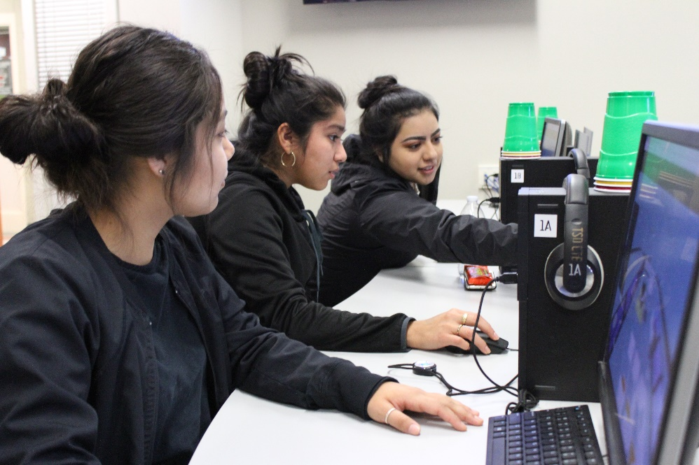**Educational Technology Learning Standards: Grades K-2**

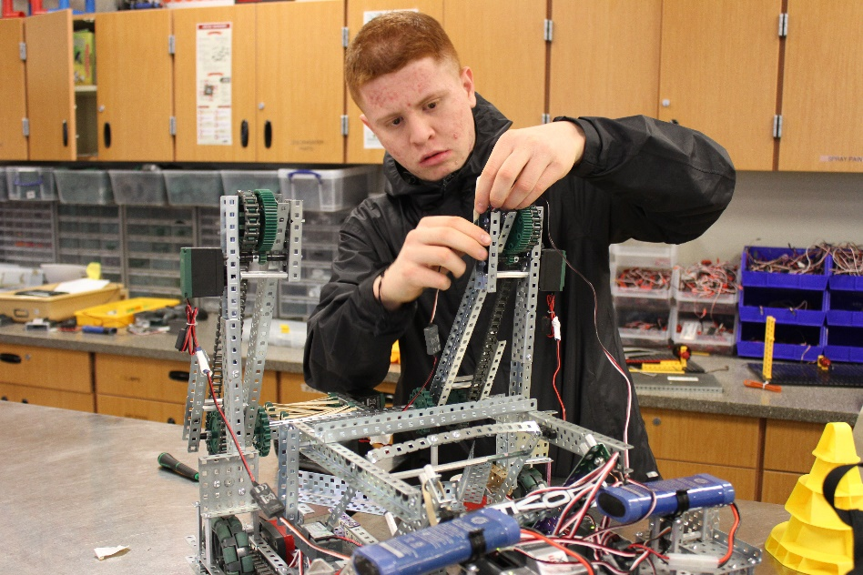

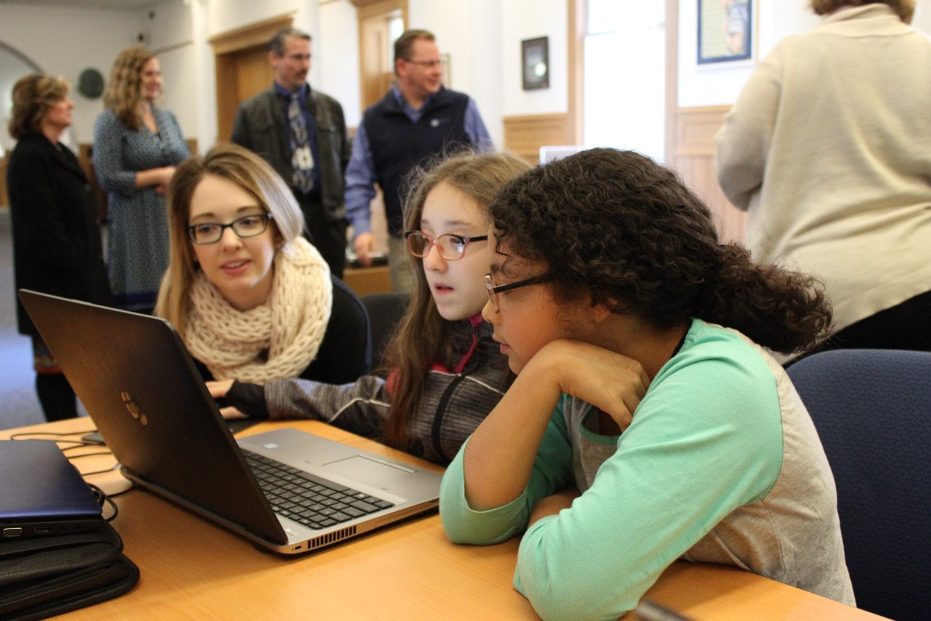

***Adopted May, 2018***

*****Photos: Toppenish High School, Sunnyside High School and OSPI, courtesy of OSPI***

# For complete K-12 Educational Technology Standards go to:

[*http://www.k12.wa.us/EdTech/Standards/default.aspx*](http://www.k12.wa.us/EdTech/Standards/default.aspx)

**Creative Commons Attribution-NonCommercial LIcense Logo (CC BY NC)
**

Except where otherwise noted, the Washington Educational Technology K–12 Learning Standards (<http://www.k12.wa.us/edtech/Standards>) by the Office of Superintendent of Public Instruction (<http://k12.wa.us/>) are licensed under a Creative Commons Attribution Non-Commercial 4.0 International License (<https://creativecommons.org/licenses/by-nc/4.0/>). All logos and trademarks are property of their respective owners.

Portions of this work are based on the 2016 International Society for Technology in Education (ISTE) Standards for Students (<https://www.iste.org/standards/for-students>)

ISTE Standards for Students, ©2016, ISTE (International Society for Technology in Education), iste.org. All rights reserved.

Standards referenced include:

*The College, Career, and Civic Life (C3) Framework for Social Studies State Standards: Guidance for Enhancing the Rigor of K-12 Civics, Economics, Geography, and History.* National Council for the Social Studies (NCSS),Silver Spring, MD, 2013, <https://www.socialstudies.org/c3>

*Common Core State Standards.* National Governors Association Center for Best Practices and Council of Chief State School Officers, Washington D.C., 2010, <http://www.corestandards.org>

*CSTA K-12 Computer Science Standards.* Computer Science Teachers Association*,* Albany, NY, 2017, <http://www.csteachers.org/page/standards>

Next Generation Science Standards: For States, By States.The National Academies Press, Washington D.C., 2013, <https://www.nextgenscience.org>

# 2018 Standards for Technology Literate & Fluent Students

***(Based upon 2016 ISTE Student Standards)***

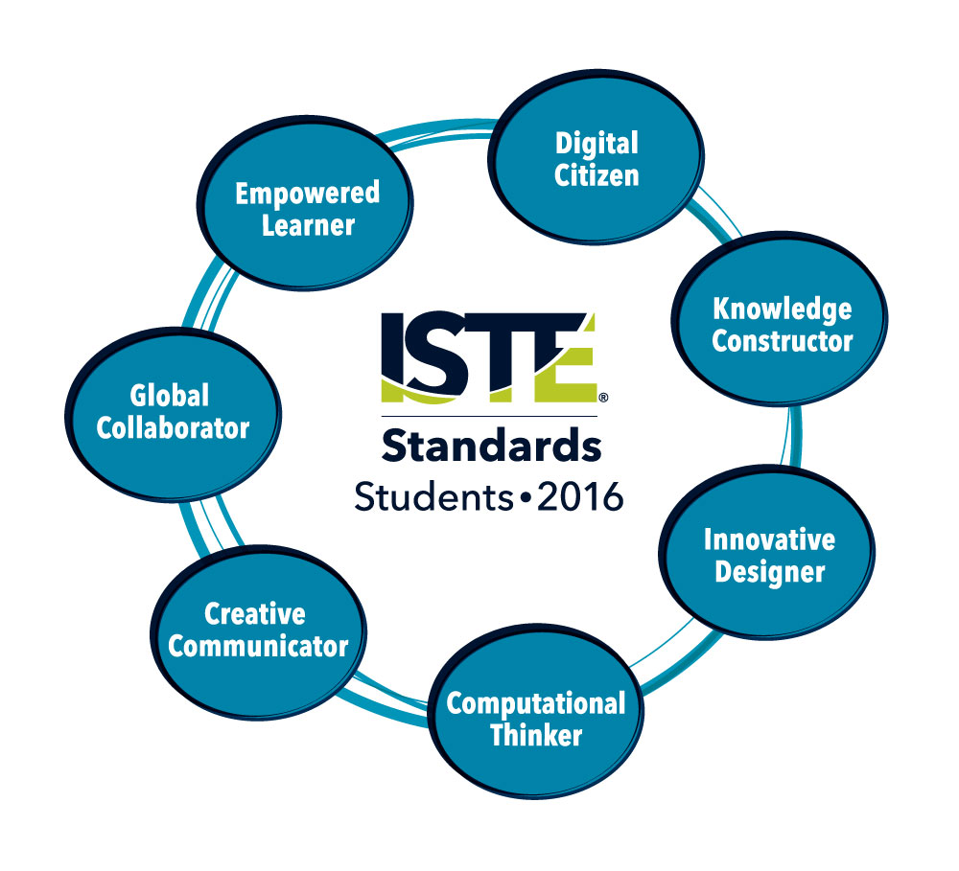

1. **Empowered Learner** - Students leverage technology to take an active role in choosing, achieving and demonstrating competency in their learning goals, informed by the learning sciences.

2. **Digital Citizen** - Students recognize the rights, responsibilities and opportunities of living, learning and working in an interconnected digital world, and they act and model in ways that are safe, legal and ethical.

3. **Knowledge Constructor** - Students critically curate a variety of resources using digital tools to construct knowledge, produce creative artifacts and make meaningful learning experiences for themselves and others.

4. **Innovative Designer** - Students use a variety of technologies within a design process to identify and solve problems by creating new, useful or imaginative solutions.

5. **Computational Thinker** - Students develop and employ strategies for understanding and solving problems in ways that leverage the power of technological methods to develop and test solutions.

6. **Creative Communicator** - Students communicate clearly and express themselves creatively for a variety of purposes using the platforms, tools, styles, formats and digital media appropriate to their goals.

7. **Global Collaborator** - Students use digital tools to broaden their perspectives and enrich their learning by collaborating with others and working effectively in teams locally and globally.

ISTE Standards•S © 2016 International Society for Technology in Education.

# Understanding the Educational Technology Standards Framework

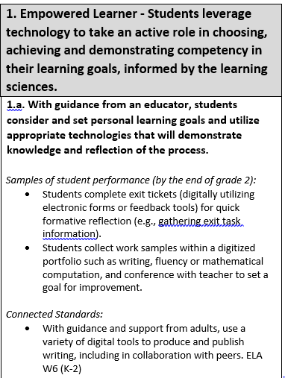

A **Standard**is a broad statement of the learning that applies to Grades K–12.

A **Performance Indicator** is a statement containing the essential content or process to be learned and the cognitive demand required to learn it. Each standard includes developmentally-appropriate grade-band performance indicators, which are considered essential to the standards.

**Samples of student performance** provide specific illustrations of the learning by the completion of the grade band. However, these examples are not exhaustive, and educators are encouraged to find multiple ways by which learners can demonstrate what they know.

**Connected standards** are logical connections to other content areas at approximately the same grade that also have a match in cognitive demand. With this alignment, teachers can expect that when students can demonstrate mastery of one standard (educational technology or other content area), they can also meet the other.

**Connected Standards Codes**

* C3= College, Career, and Civic Life (C3) Framework for Social Studies State Standards (<https://www.socialstudies.org/c3>)
* CS=Computer Science Learning Standards (<http://www.k12.wa.us/ComputerScience/>)
* H=Health Standards (<http://www.k12.wa.us/HealthFitness/Standards.aspx>)
* ELA=English Language Arts Standards (<http://www.corestandards.org/ELA-Literacy/>)
* Math=Mathematics Standards (<http://www.k12.wa.us/Mathematics/Standards.aspx>)
* PE=Physical Education Standards (<http://www.k12.wa.us/HealthFitness/Standards.aspx>)
* Science=Next-Generation Science Standards (<https://www.nextgenscience.org/get-to-know>)
* Social Studies=Social Studies Standards (<http://www.k12.wa.us/SocialStudies/EALRs-GLEs.aspx>)

# Grades K-2 Standards for Technology Literate and Fluent Students

|  |  |
| --- | --- |
| **1. Empowered Learner - Students leverage technology to take an active role in choosing, achieving and demonstrating competency in their learning goals, informed by the learning sciences.** | |
| **1.a. With guidance from an educator, students consider and set personal learning goals and utilize appropriate technologies that will demonstrate knowledge and reflection of the process.**  *Samples of student performance (by the end of grade 2):*   * Students complete exit tickets (digitally utilizing electronic forms or feedback tools) for quick formative reflection (e.g., gathering exit task information). * Students collect work samples within a digitized portfolio such as writing, fluency or mathematical computation, and conference with teacher to set a goal for improvement.   *Connected Standards:*   * With guidance and support from adults, use a variety of digital tools to produce and publish writing, including in collaboration with peers. ELA W6 (K-2) |
| **1.b. With guidance from an educator, students learn about various technologies that can be used to connect to others or make their learning environments personal and select resources from those available to enhance their learning.**  *Samples of student performance (by the end of grade 2):*   * Students participate in teacher-led connections with current events both in and outside the student’s community (e.g., videoconference, email, virtual field trips). * With guidance and support from adults, students use tools such as highlighting, video, text-to-speech, and audio, to make content accessible. * Students can identify main ideas and details while reading online digital resources. * Students know how to use communication tools in a secure environment.   *Connected Standards:*   * Create audio recordings of stories or poems; add drawings or other visual displays to stories or recounts of experiences when appropriate to clarify ideas, thoughts, and feelings. ELA SL5 (2) |
| **1.c. With guidance from an educator, students recognize performance feedback from digital tools, make adjustments based on that feedback and use age-appropriate technology to share learning.**  *Samples of student performance (by the end of grade 2):*   * Students work collaboratively with another grade level to produce and publish an e-book within the school's domain, with feedback provided from other grade bands to improve the final product.   *Connected Standards:*   * With guidance and support from adults, use a variety of digital tools to produce and publish writing, including in collaboration with peers. ELA W6 (2) |
| **1.d. With guidance from an educator, students explore a variety of technologies that will help them in their learning and begin to demonstrate an understanding of how knowledge can be transferred between tools.**  *Samples of student performance (by the end of grade 2):*   * Students develop basic skills for locating and using information with digital tools and resources, including age-appropriate databases, video clips, or e-books. * Students learn how to choose and transfer information from one digital platform to another (e.g., maps, images, etc.)   *Connected Standards:*   * Select and operate appropriate software to perform a variety of tasks, and recognize that users have different needs and preferences for the technology they use. [CS 1A-CS-01](https://sites.google.com/site/cstastandards/standards) * Use appropriate terminology in identifying and describing the function of common physical components of computing systems (hardware). [CS 1A-CS-02](https://sites.google.com/site/cstastandards/standards) * Describe basic hardware and software problems using accurate terminology. [CS 1A-CS-03](https://sites.google.com/site/cstastandards/standards) * Use maps, graphs, photographs, and other representations to describe places and the relationships and interactions that shape them. C3 D3.Geo.2 (K-2) |

|  |  |
| --- | --- |
| **2: Digital Citizen - Students recognize the rights, responsibilities and opportunities of living, learning and working in an interconnected digital world, and they act and model in ways that are safe, legal and ethical.** | |
| **2.a. Students practice responsible use of technology through teacher-guided online activities and interactions to understand how the digital space impacts their life.**  *Samples of student performance (by the end of grade 2):*   * Students identify both positive and negative impacts technology can have on them. * Students explain how information shared online leaves a digital footprint or “trail.” |
| **2.b. With guidance from an educator, students understand how to be careful when using devices and how to be safe online, follow safety rules when using the internet and collaborate with others.**  *Samples of student performance (by the end of grade 2):*   * Students can explain the potential implications of interacting with others online. * Students can explain the difference between information that is likely safe and appropriate to share online, and information that should be kept private. |
| **2.c. With guidance from an educator, students learn about ownership and sharing of information, and how to respect the work of others**  *Samples of student performance (by the end of grade 2):*   * Students understand and can articulate the importance of respecting others’ belongings as they apply to digital content and information. * Students can locate an author and/or title for a digital resource. * Students understand that some digital content may be created by a company and not a single person. |
| **2.d. With guidance from an educator, students demonstrate an understanding that technology is all around them and the importance of keeping their information private.**  *Samples of student performance (by the end of grade 2):*   * Students can explain basic steps to follow when choosing a website to use for personal use (e.g., games). * Students can explain why they shouldn’t enter their personal information into a website, online game system, etc. without adult supervision.   *Connected Standards:*   * Explain what passwords are and why we use them, and use strong passwords to protect devices and information from unauthorized access. [CS 1A-NI-04](https://sites.google.com/site/cstastandards/standards) |

|  |  |
| --- | --- |
| **3. Knowledge Constructor - Students critically curate a variety of resources using digital tools to construct knowledge, produce creative artifacts and make meaningful learning experiences for themselves and others.** | |
| **3.a. With guidance from an educator, students use digital tools and resources, contained within a classroom platform or otherwise provided by the teacher, to find information on topics of interest.**  *Samples of student performance (by the end of grade 2):*   * Students use photos to illustrate how families are different and the same. * Students are able to identify simple search terms to find information in a digital resource or online library catalog. * Students can use basic search tools in an age-appropriate digital resource.   *Connected Standards:*   * Recall information from experiences or gather information from provided sources to answer a question. [ELA W8](http://www.corestandards.org/ELA-Literacy/W/2/8/) (2) * Compare and contrast the most important points presented by two texts on the same topic. [ELA R9](http://www.corestandards.org/ELA-Literacy/RI/2/9/) (2) * Understands how questions are used to find out information. Social Studies 5.2.1 (K) * Uses texts and visuals to identify the main ideas or key details to study family life. Social Studies 5.2.2 (2) |
| **3.b. With guidance from an educator, students become familiar with age-appropriate criteria for evaluating digital content**  *Samples of student performance (by the end of grade 2):*   * Students can apply basic questions to help them evaluate whether a digital resource or e-book is a good fit for them (e.g., the correct reading level). * Students can distinguish between nonfiction and fiction digital resources.   *Connected Standards:*   * Students compare and contrast the most important points presented by two texts or media productions on the same topic. ELA RI9 (2) * Students know and use various text features (e.g., captions, bold print, subheadings, glossaries, indexes, electronic menus, icons) to locate key fact for information in a text efficiently. ELA RI5(2) * Describe how reasons support specific points the author makes in a text. ELA RI8 (2) |

|  |
| --- |
| **3.c. With guidance from an educator, students explore a variety of teacher-selected tools to organize information and make connections to their learning.**  *Samples of student performance (by the end of grade 2):*   * With guidance, students use digital learning tools to add audio or visual media to clarify information. * Students can use digital organizers as a class or with a partner to support classroom learning.   *Connected Standards:*   * Recall information from experiences or gather information from provided sources to answer a question. ELA W8 (2) * Create audio recordings of stories or poems; add drawings or other visual displays to stories or recounts of experiences when appropriate to clarify ideas, thoughts, and feelings. ELA SL5 (2) * Students use information gained from the illustrations in a print or digital text to demonstrate understanding of characters, setting, or plot. ELA RL7 (2) |
| **3.d. With guidance from an educator, students explore real-world issues and problems and share their ideas about them with others.**  *Samples of student performance (by the end of grade 2):*   * Students utilize diverse media formats (e.g., website, video clip, print, digital/print weekly) to report on a shared topic, then participate in a classroom discussion on the topic using digital tools. * Students pair fiction and nonfiction digital resources.   *Connected Standards:*   * Integrate and evaluate content presented in diverse media and formats, including visually and quantitatively, as well as in words. ELA R.7 * Use technology, including the internet, to produce and publish writing and to interact and collaborate with others. ELA W.6 |

|  |  |
| --- | --- |
| **4. Innovative Designer - Students use a variety of technologies within a design process to identify and solve problems by creating new, useful or imaginative solutions.** | |
| **4.a. With guidance from an educator, students ask questions, suggest solutions, test ideas to solve problems and share their learning.**  *Samples of student performance (by the end of grade 2):*   * Students use journaling or blogging to show progress. * Students share examples of design process in science (e.g., inventions such as light bulb, airplanes, cars). * Students use digital tools to record/save questions, draw solutions, etc. * Students use digital drawing tools or projector/whiteboard to share solutions.   *Connected Standards:*   * Make sense of problems and persevere in solving them. Math P1 * Ask questions, make observations, and gather information about a situation people want to change to define a simple problem that can be solved through the development of a new or improved object or tool. Science K-2-ETS1-1 * Develop a simple sketch, drawing, or physical model to illustrate how the shape of an object helps it function as needed to solve a given problem. Science K-2-ETS1-2 * Construct an argument with reasons. C3 D4.1 (K-2) * Construct explanations using correct sequence and relevant information. C3 D4.2 (K-2) * Present a summary of an argument using print, oral, and digital technologies. D4.3 (K-2) * Ask and answer questions about arguments. C3 D4.4 (K-2) * Ask and answer questions about explanations. C3 D4.5 (K-2) * Generate questions and a particular historical source as it relates to a particular historical event or development. C3 D2.His.12 (K-2) * Generate possible reasons for an event or development in the past. C3 D2.His.14 (K-2) |

|  |
| --- |
| **4.b. Students use age-appropriate digital and nondigital tools to design something and are aware of the step-by-step process of designing.**  *Samples of student performance (by the end of grade 2):*   * Students record their step-by-step process through digital drawing or video. * Students participate in makerspace activities.   *Connected Standards:*   * Model daily processes by creating and following algorithms (sets of step-by-step instructions) to complete tasks. CS 1A-AP-08 * Ask questions, make observations, and gather information about a situation people want to change to define a simple problem that can be solved through the development of a new or improved object or tool. Science K-2-ETS1-1 * Develop a simple sketch, drawing, or physical model to illustrate how the shape of an object helps it function as needed to solve a given problem. Science K-2-ETS1-2 * Construct explanations using correct sequence and relevant information. C3 D4.2 (K-2) |
| **4.c. Students use a design process to develop ideas or creations, and they test their design and redesign if necessary**  *Samples of student performance (by the end of grade 2):*   * Students use storyboarding, planning, and revision for stop-motion videos and presentation tools. * With educator assistance, students use journaling or blogging to show progress. * Students participate in makerspace activities.   *Connected Standards:*   * Ask questions, make observations, and gather information about a situation people want to change to define a simple problem that can be solved through the development of a new or improved object or tool. Science K-2-ETS1-1 * Develop a simple sketch, drawing, or physical model to illustrate how the shape of an object helps it function as needed to solve a given problem. Science K-2-ETS1-2 |
| **4.d. Students demonstrate perseverance when working to complete a challenging task.**  *Samples of student performance (by the end of grade 2):*   * Students complete digital exit tickets (e.g., using digital feedback tools) upon project completion to reflect on and rate their effort and understanding. * With educator assistance, students use journaling or blogging to record mindset and model growth mindset regarding potential barriers or opportunities.   *Connected Standards:*   * Make sense of problems and persevere in solving them. Math P1. |

|  |  |
| --- | --- |
| **5. Computational Thinker - Students develop and employ strategies for understanding and solving problems in ways that leverage the power of technological methods to develop and test solutions.** | |
| **5.a. With guidance from an educator, students identify a problem and select appropriate technology tools to explore and find solutions.**  *Samples of student performance (by the end of grade 2):*   * Students participate in makerspace activities. * Given a variety of resources (e.g., print, online, digital), students self-select an appropriate resource to solve the identified problem.   *Connected Standards:*   * Decide when to use qualitative vs. quantitative data. Science SEP5 (K-2) * Ask questions, make observations, and gather information about a situation people want to change to define a simple problem that can be solved through the development of a new or improved object or tool. Science K-2-ETS1-1 * Develop a simple sketch, drawing, or physical model to illustrate how the shape of an object helps it function as needed to solve a given problem. Science K-2-ETS1-2 |
| **5.b. With guidance from an educator, students analyze age-appropriate data and look for similarities in order to identify patterns and categories.**  *Samples of student performance (by the end of grade 2):*   * Students can collect data (e.g., survey responses) and create charts/graphs, either individually or collectively as a class. * Students can find patterns and explore the meaning of charts, graphs, and tables. * Students use an interactive whiteboard or other interactive tool to sort and categorize various items or objects to support classroom learning.   *Connected Standards:*   * Analyze data from tests of two objects designed to solve the same problem to compare the strengths and weaknesses of how each performs. Science K-2-ETS1-3 * Collect and present the same data in various visual formats. [CS 1A-DA-06](https://sites.google.com/site/cstastandards/standards) * Identify and describe patterns in data visualizations, such as charts or graphs, to make predictions. [CS 1A-DA-07](https://sites.google.com/site/cstastandards/standards) * Integrate and evaluate content presented in diverse media and formats, including visually and quantitatively, as well as in words. ELA CCR.R7 |
| **5.c. With guidance from an educator, students break a problem into parts and identify ways to solve the problem.**  *Samples of student performance (by the end of grade 2):*   * Students can communicate design plans and solutions using a variety of communication options (e.g., drawing and oral or written descriptive language).   *Connected Standards:*   * Decompose (break down) the steps needed to solve a problem into a precise sequence of instructions. [CS 1A-AP-11](https://sites.google.com/site/cstastandards/standards) |
| **5.d. Students understand how technology is used to make a task easier or repeatable and can identify real-world examples.**  *Samples of student performance (by the end of grade 2):*   * Students can describe and provide examples of how resources such as digital tools and materials are things that help people get a task done. * Students can explain that systems have parts or components that work together to accomplish a goal.   *Connected Standards:*   * Develop programs with sequences and simple loops, to express ideas or address a problem. [CS 1A-AP-10](https://sites.google.com/site/cstastandards/standards) |

|  |  |
| --- | --- |
| **6. Creative Communicator** - **Students communicate clearly and express themselves creatively for a variety of purposes using the platforms, tools, styles, formats and digital media appropriate to their goals.** | |
| **6.a. With guidance from an educator, students choose different tools for creating something new or for communicating with others.**  *Samples of student performance (by the end of grade 2):*   * Students select appropriate digital learning tools and resources to produce and publish information. * Students participate in makerspace activities.   *Connected Standards:*   * Participate in shared research and writing projects (e.g., read a number of books on a single topic to produce a report; record science observations, create how to tutorials for mathematical concepts). ELA W7 (2) * Construct an argument with reasons. C3 D4.1 (K-2) * Construct explanations using correct sequence and relevant information. C3 D4.2 (K-2) * Present a summary of an argument using print, oral, and digital technologies. C3 D4.3 (K-2) * Construct maps, graphs, and other representations of familiar places. C3 D2.Geo.1 (K-2) |
| **6.b. Students use digital tools to create original works.**  *Samples of student performance (by the end of grade 2):*   * Students create videos, songs, artwork (e.g., using video, music, or various draw or paint applications). * Students create an animation using digital tools.   *Connected Standards:*   * With guidance and support from adults, explore a variety of digital tools to produce and publish writing, including in collaboration with peers. ELA W6 (K-2) * Add drawings or other visual displays to descriptions as desired to provide additional detail. ELA SL5 (K-1) * Create audio recordings of stories or poems; add drawings or other visual displays to stories or recounts of experiences when appropriate to clarify ideas, thoughts, and feelings. ELA SL5 (2) * Construct maps, graphs, and other representations of familiar places. C3 D2.Geo.1 (K-2) * Construct an argument with reasons. C3 D4.1 (K-2) * Construct explanations using correct sequence and relevant information. C3 D4.2 (K-2) * Present a summary of an argument using print, oral, and digital technologies. C3 D4.3 (K-2) |
| **6.c. With guidance from an educator, students share ideas in multiple ways-visual, audio, etc.**  *Samples of student performance (by the end of grade 2):*   * Using a document camera (zoom in/out, lighting, rotation, camera capture, video capture), students present their work to classmates. * Students create electronic graphs. * Students use a digital drawing program to develop illustrations that describe key details of a text, then animate these illustrations to show movement. * Students use a digital simulation to gain understanding into the interconnectivity and roles of the parts of the system. * Students use different presentation platforms (e.g., slide presentation, movie, book trailer) throughout a unit of study.   *Connected Standards:*   * Explain how the consumption of products connects people to distant places. C3 D2.Geo.11 (K-2) * Generate possible reasons for an event or development. C3 D2.His.14 (K-2) * Select which reasons might be more likely than others to explain a historical event or development. C3 D2.His.16 (K-2) * Explain why and how people, goods, and ideas move from place to place. C3 D2.Geo.7 (K-2) * Explain how weather, climate, and other environmental characteristics affect people’s lives in a place or region. C3 D2.Geo.4 (K-2) |
| **6.d. With guidance from an educator, students select technology to share their ideas with different people.**    *Samples of student performance (by the end of grade 2):*   * Students can select appropriate digital tools to create their products and presentations. * Students discuss and identify communication needs considering the task, situation and information to be shared digitally.   *Connected Standards:*   * Use technology, including the internet, to produce and publish writing and to interact and collaborate with others. ELA CCRA W.6 |

|  |  |
| --- | --- |
| **7. Global Collaborator - Students use digital tools to broaden their perspectives and enrich their learning by collaborating with others and working effectively in teams locally and globally.** | |
| **7.a. With guidance from an educator, students use technology tools to work with friends and with people outside their neighborhood, city and beyond.**  *Samples of student performance (by the end of grade 2):*   * Students utilize video/voice conferencing to connect for learning (e.g., author presentations that teach the writing process, outside experts/consultants).   *Connected Standards:*   * Work respectfully and responsibly with others online. CS 1A-IC-17 * Use listening, consensus-building, and voting procedures to decide on and take action in their classrooms. C3 D4.8 (K-2) |
| **7.b. With guidance from an educator, students use technology to communicate with others and to look at problems from different perspectives.**  *Samples of student performance (by the end of grade 2):*   * Students collaborate using online software so that multiple perspectives can be captured. * Students participate in global collaborative projects utilizing video/voice conferencing. * Students record and share their perspectives with supporting reasoning using digital tools.   *Connected Standards:*   * Identify and explain a range of local, regional, and global problems, and some ways in which people are trying to address these problems. C3 D4.6 (K-2) * Follow agreed-upon rules for discussions while responding attentively to others when addressing ideas and making decision as a group. C3 D2.Civ.9 (K-2) * Compare their own point of view with others’ perspectives. C3 D2.Civ.10 (K-2) * Describe why people in one country trade goods and services with people in other countries. C3 D2.Eco.14 (K-2) * Describe products that are produced abroad and sold domestically and product that are produced domestically and sold abroad. C3 D2.Eco.15 (K-2) * Compare how people in different types of communities use local and distant environments to meet their daily needs. C3 D2.Geo.8 (K-2) * Identify ways that a catastrophic disaster may affect people living in a place. C3 D2.Geo.12 (K-2) |
| **7.c. With guidance from an educator, students take on different team roles and use age-appropriate technologies to complete projects.**  *Samples of student performance (by the end of grade 2):*   * Students work collaboratively to create a digital product (e.g., slideshow, concept mapping/webbing, video, poster, text document), and assume roles such as writer, recorder, editor, artist or graphics placer.   *Connected Standards:*   * Use listening, consensus-building, and voting procedures to decide on and take action in their classrooms. C3 D4.8 (K-2) |
| **7.d. With guidance from an educator, students use age-appropriate technologies to work together to understand problems and suggest solutions.**  *Samples of student performance (by the end of grade 2):*   * Students view global images and micro-write or record reactions and solutions using digital tools.   *Connected Standards:*   * With guidance and support from adults, use a variety of digital tools to produce and publish writing, including in collaboration with peers. ELA W6 (K-2) * Identify ways to take action to help address local, regional, and global problems. C3 D4.7 (K-2) |

# Glossary

**Acceptable/Responsible Use Policy (AUP/RUP):** A school or organization’s official policy statement regarding the use of the Internet or other computer networks.

**Algorithm**: A process or set of steps to be followed in calculations or other problem-solving operations, especially by a computer.

**Authentic Problem:**

A genuine, real or original problem to be solved.

**Blogging:** The process of writing a blog (also known as a Weblog), an online journal in which the writer shares their thoughts about a particular subject with readers.

**Cloud computing:** The practice of storing and accessing data and programs over the Internet rather than a local server or a personal computer (e.g., iCloud, Google Cloud, OneDrive and Dropbox).

**Cookie**: A piece of code or data created by a web server and stored on a user's computer. It is used to keep track of the user's usage patterns and preferences.

**Creative Commons:** Creative Commons licenses are designed to facilitate and encourage more versatility and flexibility in copyright law.

**Cybersecurity:** Measures taken to protect networks, computers, programs and data from attack, damage or unauthorized access**.**

**Design Process**: An approach for breaking down a large project into manageable chunks.

**Digital Footprint**: The information about a particular person that exists on the Internet as a result of their online activity A digital identity is an online or networked identityadopted or claimed in cyberspace by an individual, organization or electronic device.

**Digital Portfolio:**  A collection of electronic evidence assembled and managed by a user. Also known as an e-portfolio or an electronic portfolio.

**Digital Stories:** A variety of forms of digital narratives (web-based stories, interactive stories, hypertexts and narrative computer games).

**Digital Tools:** Hardware and software that generate, store and process data.

**Ebook**: An electronic version of a printed book that can be read on a computer or handheld device designed specifically for this purpose.

**Encryption**: The process of converting electronic data to an unrecognizable or encrypted form, one that cannot be easily understood by unauthorized parties.

**Infographic:** A visual image such as a chart or diagram used to represent complex information or data quickly and clearly.

**Learning Management System (LMS):** A software application or Web-based technology used to plan, implement, and assess a specific learning process. Typically, an LMS provides an instructor with a way to create and deliver content, monitor student participation, and assess student performance.

**Makerspace:** A makerspace is a place where students can gather to create, invent, tinker, explore and discover using a variety of tools and materials.

**Malware:** The broad term to describe any malicious software designed by hackers. Malware includes viruses, worms, spyware, trojans, keyloggers, zombie programs and any other software that seeks to do one of four things: vandalize your computer in some way; steal your private information; take remote control of your computer (zombie your computer) for other ends; or manipulate you into purchasing something.

**Microcontroller:** A compact integrated circuit which is dedicated to perform one task and execute one specific application. A typical microcontroller includes a processor, memory and input/output peripherals on a single chip.

**Multimedia:** Digital products that integrate interactive text, images, sound and color. Multimedia can be anything from a simple PowerPoint slide show to a complex interactive simulation.

**Network:** A collection of computers that are linked together for the purpose of sharing information.

**Podcast:** A media file that is distributed over the Internet using syndication feeds, for playback on portable media players and personal computers.

**Pop-ups:** A secondary web browser window of varying size, often containing a form of advertising, which opens outside of the primary web browser window.

**Social Media**: The broad term for any online tool that enables users to interact with thousands of other users (e.g., Facebook, Twitter, LinkedIn, Google+, Instagram, Pinterest, Snapchat, Tumblr and Reddit).

**Virtual Field Trip:** A guided exploration through the World Wide Web that organizes a collection of pre-screened, thematically based web pages into a structured online learning experience.

**Virus:** A piece of programming code inserted into other programming to cause damage. Viruses can be sent in many forms but are often transmitted via email messages that, when opened, may erase data or cause damage to your hard disk. Some viruses are able to enter your email system and send themselves to other people in your list of contacts.

# References

Bailey, Gerald and Mike Ribble. *Digital Citizenship in Schools*. International Society for Technology in Education (ISTE), 2007.

The Center for Universal Design in Education, DO-IT Program, University of Washington, 2018, [www.washington.edu/doit/programs/center-universal-design-education/overview](http://www.washington.edu/doit/programs/center-universal-design-education/overview).

[*Culturally Responsive Teaching: A Guide to Evidence-based Practices for Teaching All Students Equitably*](http://educationnorthwest.org/resources/culturally-responsive-teaching-guide-evidence-based-practices-teaching-all-students). Region X Equity Assistance Center (EAC) at Education Northwest, 2016, [educationnorthwest.org/sites/default/files/resources/culturally-responsive-teaching-508.pdf](http://educationnorthwest.org/sites/default/files/resources/culturally-responsive-teaching-508.pdf).

*ISTE Standards for Students*. International Society for Technology in Education (ISTE), 2016,

[www.iste.org/standards/for-students](http://www.iste.org/standards/for-students)

[*Preparing Teachers for Schools as They Are:*](https://www.google.com/url?q=http://www.k12.wa.us/Compensation/pubdocs/PreparingTeachersforSchoolsAsTheyAre1.PDF&sa=U&ved=0ahUKEwj-gYXGyYPZAhUB62MKHcszAgEQFggFMAA&client=internal-uds-cse&cx=011492945478748372637:4tjnntgeczs&usg=AOvVaw3dyqtdSxAjkPqT7RlreJ6W) *Recommendations for Cultural Competence for all Teachers in Washington State*. Cultural Competency Work Group to the Professional Educator Standards Board, 2009,[drive.google.com/file/d/0BzB1kJv-8a4iN2pzZUlYVnJVOWM/view](https://drive.google.com/file/d/0BzB1kJv-8a4iN2pzZUlYVnJVOWM/view)

*Standards for the 21st Century Learner.* American Association of School Librarians (AASL),

American Library Association, 2008.

*What is Universal Design for Learning?* Center for Applied Special Technology (CAST), 2017,

[www.udlcenter.org/aboutudl/whatisudl](http://www.udlcenter.org/aboutudl/whatisudl)