**Midazolam Delivery Procedure**



**Basic Intranasal Midazolam**

**Delivery Materials:**

1. 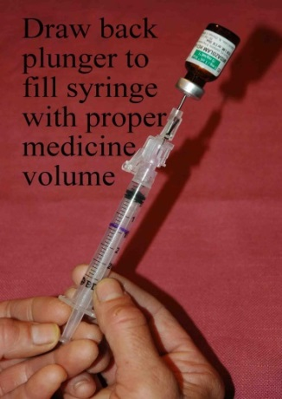Syringe and needle/needleless device to draw up the medication
2. Atomizer
3. Midazolam of appropriate concentration for nasal medication delivery
   * High concentration - Low volume
   * 5 mg/ml generic midazolam or
   * Compounded in pharmacy to 25 mg/ml (revise all dose volume calculations)

**Procedure:**

1. Aspirate the proper volume of midazolam required to treat the patient (0.2 to 0.3 mg/kg for seizures, 0.5 mg/kg for sedation) – (an extra 0.1 ml of medication should be drawn up to account for the dead space within the atomizer at the end of the procedure.)

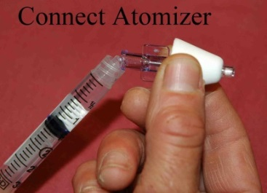

1. Twist off/remove the syringe from the needle/needleless device
2. Attach the atomizer tip via Luer lock mechanism – it twists into place.

* Slip Luer is also effective as long as the tip is firmly seated on the syringe tip and you hold it against the patients nose while delivering

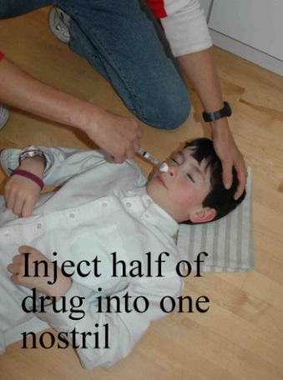

1. Using your free hand to hold the crown of the head stable, place the tip of the atomizer snugly against the nostril aiming slightly up and outward towards the top of the ear on the same side.
2. Briskly compress the syringe plunger to deliver half of the medication into the nostril.
3. Move the device over to the opposite nostril and administer the remaining medication into that nostril.

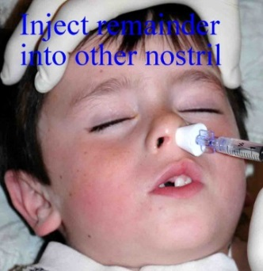

**Skills Checklist for Intranasal Midazolam Administration**

|  |  |  |  |
| --- | --- | --- | --- |
| **Intranasal Midazolam Administration Skills**  **Needed by the Trainee** | **Instruction Provided** | **Return Demonstration Stated Understanding** | **Comments** |
| States understanding that the student’s individual seizure health care plan and current medication authorization for Intranasal Midazolam must be followed. | Click or tap here to enter text. | Click or tap here to enter text. | Click or tap here to enter text. |
| States correct name of the medication. | Click or tap here to enter text. | Click or tap here to enter text. | Click or tap here to enter text. |
| States correct dose of the medication (may read this from the current medication authorization). | Click or tap here to enter text. | Click or tap here to enter text. | Click or tap here to enter text. |
| States when to administer the mediation (may read this from the current medication authorization). | Click or tap here to enter text. | Click or tap here to enter text. | Click or tap here to enter text. |
| Identifies supplies: syringe, needle, nasal atomizer tip (these may come in a sealed package), and medication vial. | Click or tap here to enter text. | Click or tap here to enter text. | Click or tap here to enter text. |
| **Proper technique for Intranasal Midazolam administration:**   1. Obtain supplies. 2. Remove plastic cap from the needle (vial adapter) and set it aside. 3. Pull back on the syringe plunger until it fills with air to the 1ml or 2ml mark (depending on dose to be given). 4. Pop the protective plastic cap off the bottle. 5. Tip the vial upside down. 6. Insert the needle (vial adapter) into the medication vial and push air from the syringe into the vial. 7. Pull the plunger back and draw up the correct amount of medication for the child into the syringe. 8. Twist to remove the needle (vial adapter). 9. Twist to attach the nasal atomizer onto the syringe. 10. Assist the child to lay down on their back. 11. Using a free hand to hold the crown of the head stable, place tip of the atomizer snuggly inside the nostril. Aim slightly up and out toward the top of the ear on that same side. 12. Quickly compress the syringe plunger to deliver **HALF** of the medication into the nostril. 13. Move the device to the opposite nostril and give the rest of the medication into that nostril following, steps 11 and 12. 14. Throw the syringe and atomizer away. 15. Note time the medication was administered and inform EMS when they arrive. Give EMS the medication vial. | Click or tap here to enter text. | Click or tap here to enter text. | Click or tap here to enter text. |
| States possible side effects of administering Intranasal Midazolam (may read this from the current medication authorization). | Click or tap here to enter text. | Click or tap here to enter text. | Click or tap here to enter text. |

I have had an opportunity to ask questions about the above information. I understand my responsibility and voluntarily agree to administer intranasal Midazolam at school and school sponsored events as outlined above.

**_____________________________________________________ ________________________**

***Faculty/staff name and signature Date***

The above faculty/staff has received the above training and demonstrated sufficient understanding and skill in administration of intranasal Midazolam at school and school sponsored events.

**_____________________________________________________ ________________________**

***Registered nurse name and signature Date***