Dyslexia advisory council updates
On Monday, November 19th, the Dyslexia Advisory Council held their second convening to begin the implementation of the ESSB 6162-Early Screening of Dyslexia. Some council members joined via the Zoom Meeting platform.
November 19, 2018
OSPI and AESD staff shared highlights from the attending the International Dyslexia Association Conference in Connecticut, including the importance of screening students throughout the year, ensuring high rates of reliability for all students, and the value of having a connection between multiple student measuring tools to provide a well-rounded view of student’s progress and success.
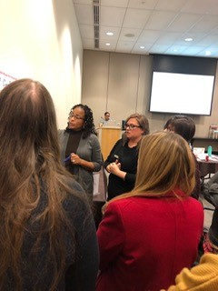Council members read “Universal Screening for Reading Problems: Why and How Should We Do This?” by Joseph R. Jenkins, Ph.D. , University of Washington, Seattle and Evelyn Johnson, Ed.D., Boise State University, Boise, ID and discussed the article in grade level bands: K, 1, and 2.
Council members provided suggestions to OSPI and AESD Staff on how to enhance Dyslexia 101 presentation for districts and schools. Council members also discussed what content should be included in the Dyslexia 1-pager infographic.
The majority of the day focused on reviewing the skills identified in statute and discussed when during the school year it would be developmentally appropriate to screen in each respective grade band.
The Request for Information (RFI) process was reviewed and it was explained how all submissions will be collected by the contracts office of OSPI, since it is a legal process with parameters set forth by the Washington State Department of Enterprise.

The February Dyslexia Advisory Council 3rd convening will be open to the public. More details to come in January 2019.

