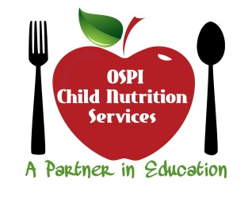
(Provided to FDCH Sponsors January 2015)
CACFP Update – National Disqualified List Access
Beginning October 2014, the USDA National Disqualified List (NDL) became accessible to sponsors of the Child and Adult Care Food Program (CACFP) and Summer Food Service Programs (SFSP). The NDL is a list of institutions and individuals that have been disqualified and terminated from participation in the CACFP and SFSP. The purpose of maintaining the NDL and making it available via the internet to sponsors is to provide a tool for promoting CACFP integrity.
Though available since October 2014, here in Washington we were unable to access the new system until December. USDA has made it clear that state agencies are still responsible for checking the NDL before a provider is approved to participate in the CACFP. Therefore, even if you choose to check the NDL before signing up a provider to be on CACFP, you must send the name to OSPI. Please send names to the CACFP Administrative Assistant, Sara Stamos, at sara.stamos@k12.wa.us. She will check the list and notify you once she has confirmed that the provider is not on the list.
The NDL system uses the USDA’s e-Authentication system. Sponsor users will need e-Authentication level one clearance to access the NDL system. If you want to access the NDL, you can obtain an e-Authentication credential here: https://www.eauth.usda.gov/mainpages/eauthWhatIsAccount.aspx
After credentials have been established, sponsor users can access the NDL here:
https://www.eauth.usda.gov/Login/login.aspx?zone=z2&TYPE=33554433&REALMOID=06-33a06771-7fc8-44c5-b003-a0631c8d244e&GUID=&SMAUTHREASON=0&METHOD=GET&SMAGENTNAME=-SM-MqA2EGHiuuF6qrkXZS9U5Kkn9laZnH0WTFX%2bCUiybmW0JDVI4xSCIzAqxyseaE5r&TARGET=-SM-HTTPS%3a%2f%2fsnp%2efns%2eusda%2egov%2fndlweb%2fWelcome%2eaction
If you have any questions, please contact Mary Nagel or Sara Stamos at 360-725-6206.

