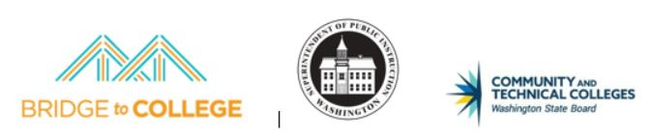
Bridge to College
School Assurances:
This school assures the Office of Superintendent of Public Instruction (OSPI) a commitment to: School leadership commits to supporting Bridge Course teachers to fully participate in course trainings and professional learning opportunities, as well as to supporting ongoing communication within the school and district regarding Bridge Course implementation. Additional assurances include:

- Release all participating teachers for meetings during the school year for Communities of Practice (CoPs) meetings and support new teacher participation in a 2‐day summer professional development institute. (Returning teachers are not required to attend the summer training but must stay certified to teach the course.)

  - August 2018 ‐ 2 full day Bridge Course Summer Institute for NEW teachers
  - Middle of October, 2018 ‐ date TBD ‐ Regional or Local Community of Practice
  - Middle of November, 2018 ‐ date TBD ‐ Regional Training or Community of Practice
  - Middle of January, 2019 ‐ date TBD ‐ Regional or Local Community of Practice
  - Middle of February, 2019 ‐ date TBD ‐ Regional Training or Community of Practice
  - Middle of April, 2019 ‐ date TBD ‐ Regional or Local Community of Practice

- Identify teachers to implement the Bridge Course who have a deep understanding of the CCSS, their instruction reflects the shifts in the CCSS and they have demonstrated evidence of successfully teaching struggling students.

- If a school or district has more than 1 participating teacher, provide formal opportunities for Bridge Course teachers to collaborate and plan with other Bridge Course teachers.

- Use specified Bridge course name and code in CEDARS and school catalogue.

Math – Bridge to College Mathematics ‐ WA 0003
  - ELA – Bridge to College English Language Arts ‐ WA 0001

- Utilize Bridge Course funds to support teacher travel costs to assure NEW teacher participation in the required Summer Institute.

- Supplement grant funding as needed for supplies and any travel or sub costs incurred during the school year for new and returning teachers.

- Respond to communications and requests from OSPI and the State Board for Community and Technical Colleges (SBCTC) in a timely manner including updating iGrants with current teacher and budget information.

- Notify students about the placement agreement that is part of the Bridge to College course.

- Collaborate with OSPI, SBCTC, and project evaluators to support Bridge Course evaluation and refinement efforts, including responding to requests for student data and providing access to classrooms and teachers for observations and gathering
- Collaborate with OSPI, SBCTC, and project evaluators to support Bridge Course evaluation and refinement efforts, including responding to requests for student data and providing access to classrooms and teachers for observations and gathering feedback related to project evaluation.
- Notify OSPI if a Bridge Course teacher is unable to complete their commitments to the full year of training and provide OSPI with a contingency plan should this occur.

