ACCESS POINT (intermediate): 3.OA.I. Student will solve one-step real-world problems using objects or models to compose or decompose numbers up to 10.
Requirements:
- Every performance task must have at least five unique items.
- Each item must have a different sum or difference.
- Task must include:
  - addition
  - subtraction
  - or a combination of both
- In a multiple-choice item, a minimum of three answer choices must be provided.

Restrictions: None

Items/Questions
Christina got 3 cookies from the kitchen. Her brother gave her 3 more. How many cookies in all does Christina have?

A. 

B.

C.

Tracy had six balls. She found three more balls. How many balls does Tracy have in all? (Read the answer choices to the student)

A. 3 balls
B. 8 balls
C. 9 balls

Jan picked 5 tomatoes from the garden. She needs 8 tomatoes in all.

How many more tomatoes did she need to pick?
- 3
- 4
- 8

Teacher direction Mr. Darnell only has two bananas. (Point to the bananas)
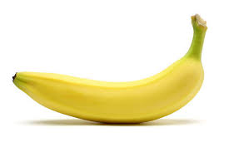
Teacher direction: Mr. Darnell needs three bananas. How many more bananas does Mr. Darnell need? (Point to, but do not quantify the answer choices for the student)
A.
B.
C.

Teacher direction: Tracy has six volleyballs. (Point to the volleyballs)

Teacher direction: Tracy needs 10 volleyballs. How many more volleyballs does Tracy need? (Point to, but do not quantify the answer choices for the student)
A.
B.
C.

Teacher direction: Tami only has five baseballs. (Point to the baseballs)

Teacher direction: Tami needs eight baseballs. How many more baseballs does Tami need? (Point to, but do not quantify the answer choices for the student)
A.
B.
C.

Teacher direction: Marcus has one toy car. (Point to the toy car)
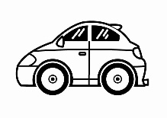
Teacher direction: Marcus needs seven toy cars. How many more toy cars does Marcus need? (Point to, but do not quantify the answer choices for the student)
A.
B.
C.

Teacher direction: Max only has one phone. (Point to the phone)
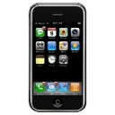
Teacher direction: Max needs nine phones. How many more phones does Max need?
A.
B.

C.

Teacher direction: Damon has three computers. (Point to the computers)

Teacher direction: Damon needs six computers. How many more computers does Damon need?
A.
B.
C.

Teacher direction Mr. Darnell has two soccer balls. (Point to the soccer balls)

Teacher direction: Mr. Darnell needs thee soccer balls. How many more soccer balls does Mr. Darnell need? (Point to, but do not quantify the answer choices for the student)
A.

B.

C.
Teacher direction: Minnie only has one cat. (Point to the cat)

Teacher direction: Minnie needs ten cats. How many more cats does Minnie need? (Point to, but do not quantify the answer choices for the student
A.
B.
C.

Teacher direction: Tami has five volleyballs. (Point to the volleyballs)

Teacher direction: Tami needs eight volleyballs. How many more volleyballs does Tami need? (Point to, but do not quantify the answer choices for the student)
A.
B.
C.

Teacher direction: Mr. Damon has one computer. (Point to the computers)
Teacher direction: Mr. Damon needs nine computers. How many more computers does Mr. Damon need? (Point to, but do not quantify the answer choices for the student.)
A.
B.
C.

Teacher direction: Marcus has two toy cars. (Point to the toy cars)
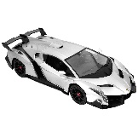
Teacher direction: Marcus needs ten toy cars. How many more toy cars does Marcus need? (Point to, but do not quantify the answer choices for the student)
A.
B.
C.

Teacher direction: Mr. Bob has 1 wrench. (Point to the wrenches)
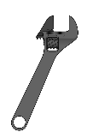
Teacher direction: Mr. Bob needs 5. How many more wrenches does Mr. Bob need? (Point to, but do not quantify the answer choices for the student)
A.
B.
C.

Mary has four dollars.
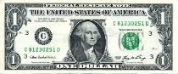
A book about horses she wants costs nine dollars.
How many dollars does she still need?
- two 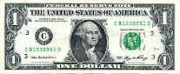
- four 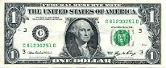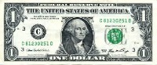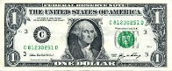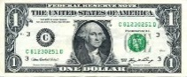
- five

Mary had four stickers. She earned four more stickers.

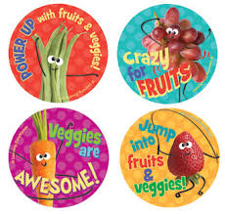

How many stickers does she have in all?
- 2
- 4
- 8

Mark has seven colored pencils.
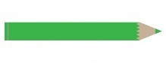

He loses two pencils.

How many pencils does Mark have left?

A. three
B. five
C. six

