Name: Class: Date:
The Treaty of Greenville and Its Underlying Intent
As you read the entry below, keep in mind the following questions:
- Why would the Indian nations cede (give up) so much territory?
- What did the Indian nations get in return?
- What was the real purpose of the treaty?
Treaty of Greenville (1795) treaty to negotiate peace between the U.S. government and Indian tribes in the Old Northwest Territory and to obtain land cessions
A year after the battle of Fallen Timbers (1794), in which the American general Anthony Wayne defeated Indian forces in Indiana, Wayne called a meeting of tribes in the Old Northwest Territory to conclude a peace treaty. Wayne was also instructed by the government to obtain the surrender of much of the Indians’ land in present-day Ohio and Indiana.
In the summer of 1975, some 1,130 chiefs and warriors assembled at Fort Greenville in western Ohio. The Indian leaders who attended represented a number of tribes, including the Lenni Lenape (Delaware), Shawnee, Ottawa, Chippewa, Miami, Kickapoo, and Potawatomi. After several days of talks and assurances of future peace on both sides, Indian leaders and Wayne signed the Treaty of Greenville on August 3, 1795. In addition to agreeing to peace, the tribes ceded an enormous part of their territory: two-thirds of modern Ohio, a large area of eastern Indiana, and other lands in Michigan. For ceding eastern and southern Ohio, the tribes were to receive $20,000 in goods and were promised an annual payment of $9,500 [in perpetuity].
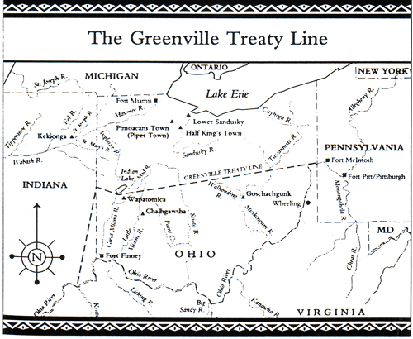
Part of the treaty included the establishment of a boundary between the lands the Indians would retain and those open to settlement. Called the Greenville Line, the boundary ran along the Cuyahoga River to the Maumee and Wabash Rivers to a point on the Ohio River opposite the mouth of the Kentucky River. The tribes were to retain lands west and north of the Greenville Line, with the exception of Detroit and several French settlements to the north. The United States also reserved 150,000 acres of land around the Ohio River in Kentucky, which was given as a reward to veterans of the American Revolution (1775 – 81) who fought with General George Rogers Clark in that region.
The Indians believed that the Treaty of Greenville had guaranteed their remaining lands in the Old Northwest Territory and that the established boundary between the tribes and non-Indian settlement was secured. But in fact the U.S. government was simply buying a period of peace in its efforts to expand its frontiers westward to the Mississippi River. Among Wayne’s instructions was a letter from the U.S. secretary of war observing that more Indian lands could be obtained as settlers advanced onto the frontiers. The Treaty of Greenville was therefore of major significance in pushing the frontier westward. The vast territory beyond the Ohio valley was opened to settlement, with little fear of conflict with Indian tribes.
The Treaty of Greenville also set a precedent for objectives in future treaties with Indians—that is, obtaining cessions of land, advancing the frontier through white settlement, and obtaining more cessions through treaties. With the tribes’ surrender of most of Ohio, settlers began entering in Northwest Territory in greater numbers. In the near future, more treaties would further diminish Indians’ territory.
Kessel, William B., PhD., and Robert Wooster, PhD. Encyclopedia of Native American Wars & Warfare. Facts on File. New York, NY, 2005. 152.
Image: http://www.jedsmithlegacy.com/GreenvilleTreatyLine.jpg

