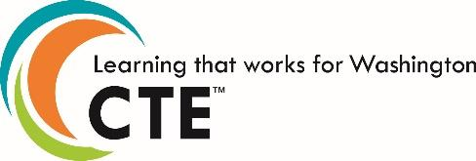

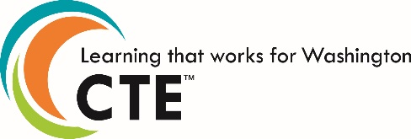

Statewide Framework Document for:

**Course Title**

Standards may be added to this document prior to submission but may not be removed from the framework to meet state credit equivalency requirements. Performance assessments may be developed at the local level. In order to earn state approval, performance assessments must be submitted within this framework. **This course is eligible for .**

The Washington State Science Standards performance expectations for high school blend core ideas (Disciplinary Core Ideas, or DCIs) with scientific and engineering practices (SEPs) and crosscutting concepts (CCCs) to support students in developing usable knowledge that can be applied across the science disciplines. These courses are to be taught in a [three-dimensional manner](http://nextgenscience.org/three-dimensions). The details about each performance expectation can be found at [Next Generation Science Standards](http://nextgenscience.org/next-generation-science-standards).

Washington Mathematics Standards (Common Core State Standards) support foundational mathematical knowledge and reasoning. While it is important to develop a conceptual understanding of mathematical topics and fluency in numeracy and procedural skills, teachers should also focus on the application of mathematics to career fields to support the three (3) key shifts of CCSS. The Standards for Mathematical Practice develop mathematical habits of mind and are to be modeled and integrated throughout the course. The details about each mathematical standard can be found at [Common Core Mathematics Standards](http://www.corestandards.org/Math/).

Washington English Language Arts Standards (Common Core State Standards) establish guidelines for literacy in history/social studies, science, and technical subjects. The College and Career Readiness Anchor Standards form the backbone of the ELA/literacy standards by articulating core knowledge and skills, while grade-specific standards provide additional specificity. The details about English Language Arts Standards can be found at [Common Core English Language Arts Standards.](http://www.corestandards.org/ELA-Literacy/)

|  |  |  |
| --- | --- | --- |
| **School District Name** | | |
| **Course Title:** | | **Total Framework Hours:** |
| **CIP Code:** | ExploratoryPreparatory | **Date Last Modified:** |
| **Career Cluster:** | | **Cluster Pathway:** |
| **Course Summary**: | | |
| **Eligible for Equivalent Credit in:** | | **Total Number of Units:** |
| **Course Resources:** | | |

*To duplicate this blank table (for additional units), select the table, select copy, place cursor below the first table, and select paste.*

|  |  |  |  |  |
| --- | --- | --- | --- | --- |
| **Unit 1:** | | | | **Total Learning Hours for Unit:** |
| **Unit Summary**: | | | | |
| **Performance Assessments**:(Districts to complete for each unit)  *Example assessments for this unit include:*   * *Demonstrate knowledge and skills of Robotics lab safety* | | | | |
| **Leadership Alignment**: (Districts to complete for each unit)  *Leadership alignment must include a unit specific project/activity that aligns with the 21st Century Leadership Skills.*  *Example: Students will develop a safety plan for the robotics classroom.*  *1.B.1: Develop, implement and communicate new ideas to others effectively* | | | | |
| **Industry Standards and/or Competencies**: | | | | |
| **Aligned Washington State Academic Standards** | | | | |
| **Arts** |  | | | |
| **Educational Technology** |  | | | |
| **Health Education** |  | | | |
| **Physical Education** |  | | | |
| **English Language Arts: Common Core** |  | | | |
| **Mathematics: Common Core** |  | | | |
| **Mathematical Practices** |  | | | |
| **Science** |  | | | |
| **Science and Engineering Practice** | | **Disciplinary Core Idea** | **Crosscutting Concept** | |
|  | |  |  | |
| **Social Studies** |  | | | |
| **World Languages** |  | | | |