|  |  |
| --- | --- |
| **School Name:** | **Date**: |
| **Empathy Interviewees:** (Ex: Students, Staff, etc.) | **Questions Asked:** |

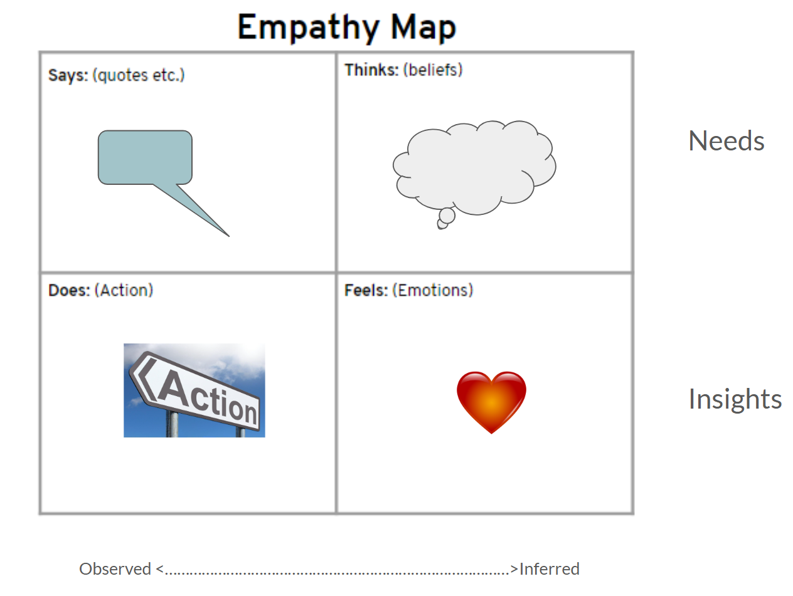

|  |  |
| --- | --- |
| Says: | Thinks: |
| Actions: | Feel/Emotions: |