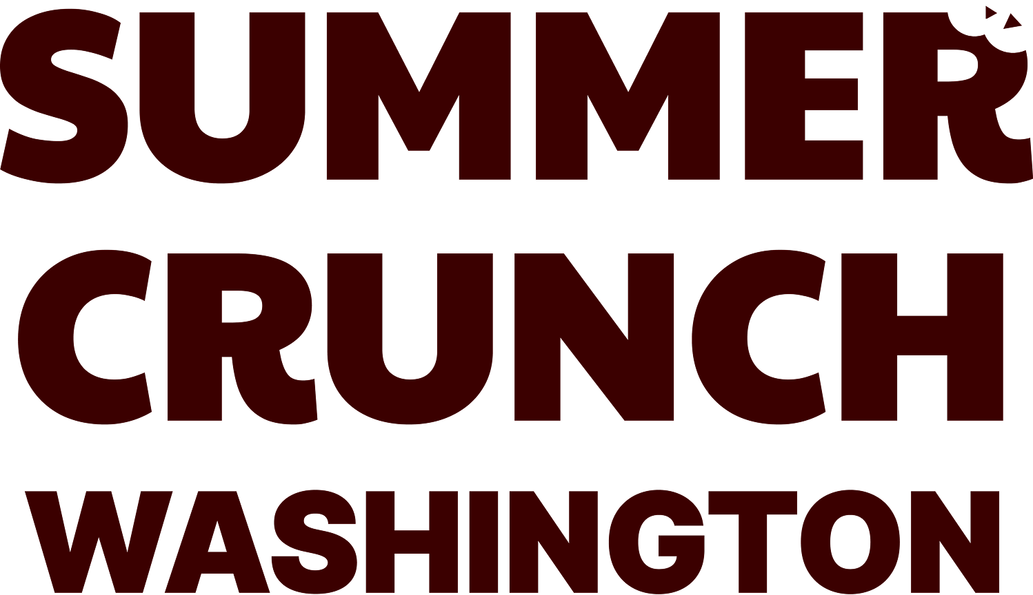

Farm to Summer Week

Social Media Content Toolkit – Quick Guide

What’s in this document:
This toolkit includes 4 ready-to-use social media content copies.

How to use:
Choose any of the content copies and pair them with a visual asset—such as a program flyer or graphics—available in the ‘Summer Crunch’ toolkit.

Customizable visual assets:
Use the following visual assets to pair with the social media content copies. Access the Canva templates using the links below.
- Summer Crunch Flyers and Social Media Graphic Templates

Post recommendation:
- Post Frequency : We recommend publishing one post one week prior to the event, a second post 1–2 days before the event, and a final post on the day of the event. Optionally, you may include an additional post after the event to share your event highlights.
- Promote with Real-Time Event Photos: On the day of and following the event, we highly encourage using photos from your site events to boost engagement and showcase participation. You can find customizable graphic templates in the graphic toolkit.
- Hashtag use suggestions: #summercrunch #WAedu #WAsummercrunch

Social media copies for use:

[OPTION #1] Very General
Farm to Summer Week keeps the Farm to School connection going all summer long—helping kids stay nourished and connected to Washington-grown food.
New this season: Summer Crunch!
A statewide celebration of locally grown crunchy produce at summer meal sites.
[Sponsor Name] will be serving up fresh, crunchy, Washington-grown food on [DATE] at [SITE]—plus fun activities for everyone to enjoy!
Join us for a day full of crunch, fun, and hands-on learning on [DATE].

[OPTION #2] Produce Focus
Bored of the summer heat? Cool off with a crunch! 🥕❄️✨
[Sponsor Name] is proud to be part of Farm to Summer Week, bringing fresh, Washington-grown [produce name] to students’ summer meals.
Join us for our statewide celebration—Summer Crunch—on [DATE] at [SITE]!
We’ll have the crunchy [food name] ready—plus plenty of fun activities to learn, explore, and enjoy local food!
Don’t miss it—join us on [DATE]!

[OPTION #3] Produce Focus
Summer Crunch is almost here! ☀️🍒
This time we’re highlighting [Produce name. e.g.cherry 🍒]
Do you know [Fun facts about the produce. e.g. Cherries are one of the top antioxidant-rich foods] ?
Catch [Sponsor Name] at [SITE] on [DATE], serving sweet, crunchy [Produce name. e.g.cherry 🍒] and leading fun, hands-on activities.
We can’t wait to see you there!

[OPTION #4] Share the event highlights
We loved seeing our community come together to celebrate local food. 🍒🥕
Thank you to everyone who joined Summer Crunch—from tasting fresh, Washington-grown food to enjoying hands-on activities, it was a day full of fun and learning!
Let’s keep it going—support local food, stay healthy, and stay engaged all summer long. 🌱

