Addressing Disproportionality Plan
Under ESEA Section 1112(b)(2), Local Education Agencies (LEAs) are required to identify and address any disparities that result in low-income and minority students being taught at higher rates than other students by ineffective, out-of-field, and inexperienced teachers in Title I, Part A (Title IA) schools.
*Upload the completed plan to Title I, Part A Program Review Item 1.11 in EGMS. Note: District Program Review leads received notification if they were required to submit this plan.
Section 1 — How to Access and Review Data
- Access the Teacher Qualifications Comparison Workbook (see directions below).
- Review the most current data for Inexperienced, Out-of-field, and Limited Certificate status teachers for comparisons 1, 3 and 4.
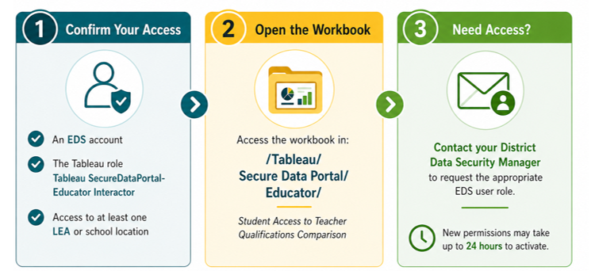
Data Comparisons
Name of LEA
The most recent data identified disproportionality in the following areas:
Item | Comparison 1  Title IA Low Income (LI) vs. Title IA Non-Low-Income (NLI) | Comparison 3  Title IA Low-Income vs. Non-Title IA Low-Income | Comparison 4  Title IA Low-Income vs. Non-Title IA Non-Low-Income
Inexperienced
Limited Certificate
Out-of-field
Ineffective
(coming soon)

Section 2 –Complete Plan
Step 1— Root Cause Analysis
To address the disproportionality identified above, conduct a Root Cause Analysis to determine the reason(s) for the disproportionality. Then respond to the question below.
Category | Selections
Root Cause Analysis (Check all that apply) | ☐ Limited applicant pool  ☐ Hiring/assignment policy gaps  ☐ Lack of endorsement pathways  ☐ Retention issues in high-need areas  ☐ Other:

Step 2 – Strategies to Address Disproportionality
After the LEA has identified disproportionality, which strategies will the LEA implement? Check the boxes that apply:
Category | Selections
Increase Access to Experienced Teachers | ☐ Support job-embedded learning walks or peer observations.  ☐ Stipends for teachers to attend instructional rounds or lesson study groups outside of the contracted day.  ☐ Provide mentor stipends and release time for mentors and mentees.  ☐ Instructional coaching for novice teachers.  ☐ Other:
Increase Access to Fully Certificated Teachers | ☐ Fund endorsements (testing/tuition)  ☐ Partner with state-approved universities for grow-your-own pipelines.  ☐ Reimburse teacher certification program costs.  Other:
Increase Access to In-Field Teachers | ☐ Reimbursement of test fees to add an endorsement.  ☐ Tuition reimbursement to add endorsement(s) through a state-approved program.  ☐ Differential pay to attract fully endorsed teachers to high-need schools.  ☐ Other:
Increase Access to Effective Teachers | ☐ PD aligned to evaluation outcomes.  ☐ Implement co-teaching models in struggling classrooms.  ☐ Trauma-informed or culturally responsive teaching PD.  ☐ Other:

