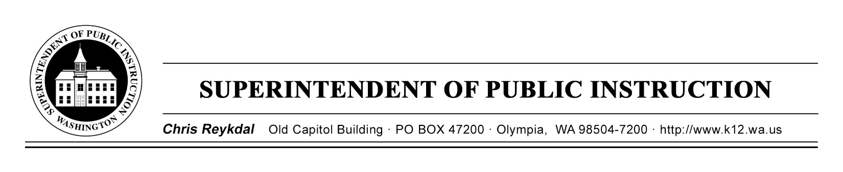

April 11, 2019 ( ) Action Required
( X ) Informational

BULLETIN NO. 019-19 STUDENT TRANSPORTATION

TO: Educational Service District Superintendents
Chief School District Superintendents
Assistant Superintendents for Business and/or Business Managers
School District Transportation Administrators
Regional Transportation Coordinators

FROM: Chris Reykdal, Superintendent of Public Instruction

RE: Student Transportation Key Performance Indicators

CONTACT: Patti Enbody, Interim Director
360-725-6122, patti.enbody@k12.wa.us

PURPOSE/BACKGROUND

In association with the Student Transportation Allocation Reporting System (STARS) efficiency rating system, the Office of Superintendent of Public Instruction (OSPI) and the Regional Transportation Coordinators have developed a limited number of key performance indicators (KPI). A Key Performance Indicators Technical Assistance Paper (TAP) customized for each school district is available on OSPI’s STARS website under the Efficiency Ratings tab.

As with the STARS Efficiency Ratings, the KPIs do not provide an absolute measurement of efficiency, since different districts have different demographic and geographic constraints. However, the values of the district’s KPI reviewed on a year to year basis can be helpful in a self-evaluation of the district’s transportation operations.

For assistance with understanding your district’s KPI, please contact your Regional Transportation Coordinator. Their contact information is provided on page 2.

BULLETIN NO. 019-19 ST
Page 2
April 11, 2019

Region 1 (ESD 112 & Capitol Region 113)  Rodney McKnight  ESD 112  2500 NE 65th Avenue  Vancouver, WA 98661-6812  360-952-3595  rodney.mcknight@esd112.org | Region 2 (Olympic ESD 114 & PS ESD 121)  Mike Shahan  Puget Sound ESD 121  1282 Valentine Ave SE  Pacific, WA 98047  253-778-7955, or 1-800-664-4549 ext. 7955  mshahan@psesd.org
Region 3 (NW ESD 189)  Mark Dennis  Northwest ESD 189  1601 “R” Avenue  Anacortes, WA 98221  360-299-4008  mdennis@nwesd.org | Region 4 (ESD 105, NC ESD 123, & ESD 171)  Dan Payne  ESD 105  33 S. Second Avenue  Yakima, WA 98902  509-454-3105  dan.payne@esd105.org
Region 5 (NEW ESD 101)
Chris Jose
NEW ESD 101
4202 South Regal
Spokane, WA 99223-7738
509-789-3558
cjose@esd101.net

INFORMATION AND ASSISTANCE

Other questions concerning this report may be directed to Patti Enbody, Interim Director for Student Transportation, at 360-725-6122 or patti.enbody@k12.wa.us. The OSPI TTY number is 360-664-3631.

This bulletin is also available on OSPI’s Bulletins and Memoranda website.

T.J. Kelly Patti Enbody
Interim Chief Financial Officer Director
K-12 Financial Resources Student Transportation

CR:tcl

OSPI provides equal access to all programs and services without discrimination based on sex, race, creed, religion, color, national origin, age, honorably discharged veteran or military status, sexual orientation, gender expression, gender identity, disability, or the use of a trained dog guide or service animal by a person with a disability. Questions and complaints of alleged discrimination should be directed to the Equity and Civil Rights Director at 360-725-6162/TTY: 360-664-3631; or P.O. Box 47200, Olympia, WA 98504-7200; or equity@k12.wa.us.

