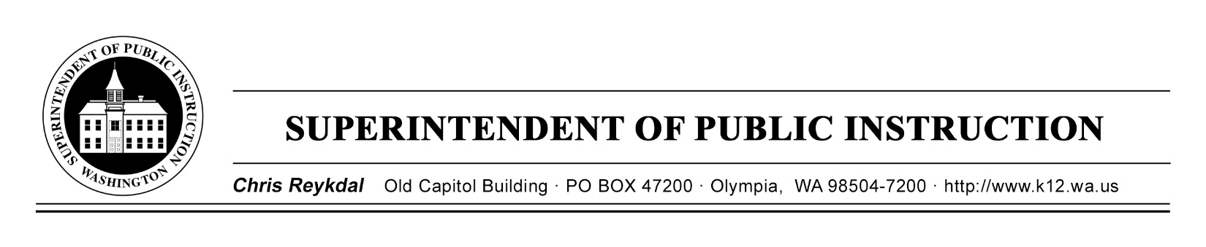

October 10, 2019 ( ) Action Required
( X ) Informational

BULLETIN NO. 073-19 STUDENT TRANSPORTATION

TO: Educational Service District Superintendents
School District Superintendents
School District Business Managers
Elementary School Principals
School Safety Patrol Coordinators
Transportation Administrators
Regional Transportation Coordinators

FROM: Chris Reykdal, Superintendent of Public Instruction

RE: School Bus Safety Week, October 21–25, 2019

CONTACT: Kim Kimbler, Administrative Program Specialist
360-725-6123, kim.kimbler@k12.wa.us

PURPOSE/BACKGROUND

This year’s National School Bus Safety Week is October 21–25. Established in 1966, by the National Association for Pupil Transportation (NAPT), the National Association for State Directors of Pupil Transportation Services (NASDPTS), and the National School Transportation Association (NSTA), this important event is intended to call attention to school bus safety and promote school bus transportation. This year’s theme is: “My School Bus, the Safest Form of Student Transportation!”

To order school bus safety week posters, please contact the American School Bus Council at: info@americanschoolbuscouncil.org.

Washington state is known nationwide for its outstanding Pupil Transportation program, and almost half of Washington’s public-school students ride school buses to and from school every day. Across Washington state, school district transportation departments ensure students arrive at school safe and ready to learn. Because of this dedication by transportation departments and the 10,800 authorized school bus drivers, Governor Jay Inslee has proclaimed October 21–25, as “School Bus Safety Week” in Washington state. An electronic copy of the Governor’s proclamation is attached to this bulletin.

Bulletin No. 073-19 ST
October 10, 2019
Page 2

The Office of Superintendent of Public Instruction encourages districts to plan events and work with local media to promote school bus safety week. It is an opportune time to focus on the safety record of school buses, as well as educate the motoring public in safely and legally sharing the road with school buses. Media resources and suggested activities can be found on NAPT's National School Bus Safety Week website.

INFORMATION AND ASSISTANCE

Questions concerning school bus safety week may be directed to Kim Kimbler, Administrative Program Specialist, at 360-725-6123, or at kim.kimbler@k12.wa.us. The OSPI TTY number is 360-664-3631.

This bulletin is also available on the Bulletins and Memos page of the OSPI website.

Jamila B. Thomas
Chief of Staff

T.J. Kelly
Chief Financial Officer
Financial Resources

Patti Enbody
Director
Student Transportation and
Traffic Safety Education

CR:kmk

Attachment: School Bus Safety Week Proclamation

OSPI provides equal access to all programs and services without discrimination based on sex, race, creed, religion, color, national origin, age, honorably discharged veteran or military status, sexual orientation, gender expression, gender identity, disability, or the use of a trained dog guide or service animal by a person with a disability. Questions and complaints of alleged discrimination should be directed to the Director of the Office of Equity and Civil Rights at 360-725-6162/TTY: 360-664-3631; or P.O. Box 47200, Olympia, WA 98504-7200; or equity@k12.wa.us.

