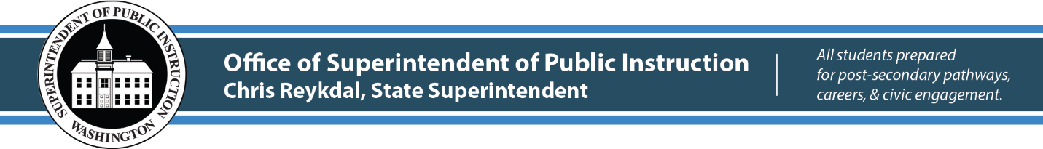

October 17, 2019 ( ) Action Required
( X ) Informational
Due date: November 8, 2019

BULLETIN NO. 074-19 OFFICE of System and school improvement

TO: Educational Service District Superintendents
School District Superintendents
School District Business Managers
High School Building Principals
High School Counselors

FROM: Chris Reykdal, Superintendent of Public Instruction

RE: U.S. Presidential Scholars Program Nominations

CONTACT: Kim Reykdal, Program Supervisor
360-725-6168, kim.reykdal@k12.wa.us

PURPOSE/BACKGROUND
This bulletin provides instructions and materials to assist high schools in submitting nominations for the U.S. Presidential Scholars Program for students who might not otherwise be nominated through the usual Scholastic Aptitude Test (SAT)/American College Test (ACT) or arts recognition processes.

The Office of Superintendent of Public Instruction (OSPI) is seeking additional nominations for the U.S. Presidential Scholars Program. All Washington state high school seniors graduating between January and August of 2020, who are U.S. citizens or legal permanent residents, and attend a Washington state public or private high school, as well as those who are homeless, are eligible to be nominated.

Under the Executive Order establishing the Presidential Scholars Program, students are selected on the basis of outstanding scholarship and promise of future success. For most of the program's existence, nominees have been invited to apply for the Presidential Scholars recognition based solely upon SAT and ACT scores or on their demonstrated ability and accomplishment in the visual and performing arts or creative writing.

BULLETIN NO. 074-19 OSSI
Page 2
October 17, 2019

Beginning in 2014, the Presidentially-appointed Commission on Presidential Scholars expanded the nominee pool by inviting each Chief State School Officer to nominate up to 20 students, 10 male and 10 female, from his or her state.

You are encouraged to nominate students who, while demonstrating outstanding scholarship, might not otherwise be nominated through the current SAT/ACT processes.

PROCESS
Each school may nominate one female student and one male student. Candidates should have demonstrated leadership; school and community involvement; and may receive discretionary points for extraordinary achievement, heavy workload, family responsibilities, or obstacles which they overcame.

To nominate a student, please complete the enclosed nomination form and include an additional one–two page writing sample from each nominated student, and postmark or submit via email by 5 pm on November 8, 2019 to:

Ronnie Larson
Office of Superintendent of Public Instruction
Post Office Box 47200
Olympia, WA 98504-7200
Email: ronnie.larson@k12.wa.us

An email will be sent to all schools, which submitted nominations in November, announcing the results.

INFORMATION AND ASSISTANCE
To learn more about the U.S. Presidential Scholars Program and the Commission on the Presidential Scholars, visit http://www2.ed.gov/programs/psp/index.html.

For questions regarding this bulletin, please contact Kim Reykdal, Program Supervisor, at 360-725-6168 or email kim.reykdal@k12.wa.us. The OSPI TTY number is 360-664-3631.

This bulletin is also available on the Bulletins page of the OSPI’S website at https://www.k12.wa.us/about-ospi/bulletinsmemos.

BULLETIN NO. 074-19 OSSI
Page 3
October 17, 2019

Michaela W. Miller, Ed.D., NBCT
Deputy Superintendent

Tennille Jeffries-Simmons
Assistant Superintendent
System and School Improvement

CR:eg

Attachment: Presidential Scholars Nomination Individual School Form

OSPI provides equal access to all programs and services without discrimination based on sex, race, creed, religion, color, national origin, age, honorably discharged veteran or military status, sexual orientation, gender expression, gender identity, disability, or the use of a trained dog guide or service animal by a person with a disability. Questions and complaints of alleged discrimination should be directed to the Equity and Civil Rights Director at 360-725-6162/TTY: 360-664-3631; or P.O. Box 47200, Olympia, WA 98504-7200; or equity@k12.wa.us.

