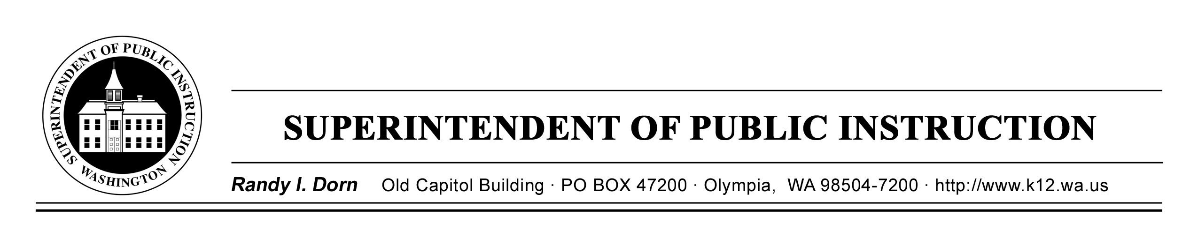

August 21, 2009 ( X ) Action Required ( X ) Informational

MEMORANDUM NO. 043-09M LEARNING AND TEACHING SUPPORT

TO: Educational Service District Superintendents
School District Superintendents
School Building Principals
School District Athletic Trainers
School District Health Services Supervisors
Private Schools Administrators

FROM: Randy I. Dorn, State Superintendent of Public Instruction

RE: Engrossed House Bill 1824 Youth Sports—Head Injury Policies

CONTACT: Gayle Thronson, R.N., M.Ed., Health Services Program Supervisor
(360) 725-6040, gayle.thronson@k12.wa.us
The agency TTY number is (360) 664-3631

The 2009 Washington State Legislature passed Engrossed House Bill 1824 Youth Sports—Head Injury Policies (1824.Session Law (1824.SL)), also to be known as the Zackery Lystedt law. The requirements of the bill will be added to RCW 4.24.660 Liability of school districts under contracts with youth programs. The Zackery Lystedt law directs each school board of directors to:
- Obtain from youth sports organizations entering into a facilities agreement with the school district a statement of compliance with policies for the management of concussion and head injury in youth sports as set forth below and in section 2 of 1824.SL.
- Work in concert with the Washington Interscholastic Activities Association (WIAA) to develop guidelines, information, and forms. These materials are intended to educate and inform coaches, youth athletes, and parents/guardians of athletes concerning the nature and risk of concussion and head injury, including continuing to play after a concussion or a head injury.
- Obtain, at least annually, a signed concussion and head injury information fact sheet from each youth athlete and the athlete’s parent and/or guardian prior to the youth athlete initiating practice or competition.

- Initiate school policy to:
  - Remove from competition, at the time of suspected injury, a youth athlete who is suspected of sustaining a concussion or head injury in a practice or game.
  - Prohibit a youth athlete who has been removed from play to return to play until the athlete is evaluated by a licensed health care provider trained in the evaluation and management of concussion and written clearance from that health care provider to return to play is received.

WIAA Concussion Management information and resources supporting 1824.SL may be found at http://www.wiaa.com/ConcussionManagement/default.htm. The Washington State School Directors’ Association (WSSDA) is developing sample school district policy and will disseminate the sample policy by late August.

While 1824.SL refers to “school districts” and does not directly mention private schools, WIAA directs “all member” schools to follow the new requirements. Additional questions or information regarding this provision should be directed to WIAA.

If you have questions concerning the Zackery Lystedt law, it is recommended you contact John Miller, WIAA Assistant Executive Director, at jmiller@wiaa.com or by calling (425) 687-8585 or (866) 545-8638. If you have questions regarding the WSSDA policy, you may contact Marilee Scarbrough, Director, Policy and Legal Services at (360) 493-9231. You may also contact Gayle Thronson, Health Services Program Supervisor, at gayle.thronson@k12.wa.us or at (360) 725-6040. The agency TTY number is (360) 664-3631.

K–12 EDUCATION

Alan Burke, Ed.D.
Deputy Superintendent

STUDENT SUPPORT

Martin T. Mueller
Assistant Superintendent

Mona Johnson, Director
Learning and Teaching Support

RD:bs

