# Land Tenure Glossary

# from Indian LAND TENURE HISTORY Foundation

## Alienated Land

* Land that has had its ownership transferred to another party.

## Allotted Land

* Reservation land the federal government distributed to individual Indians, generally in 40-, 80-, and 160-acre parcels.

## Allottee

* An individual who owns an undivided interest in a parcel of allotted land.

## Beneficial Use

* The right to benefit from (live on, use, profit from) a parcel of land, the legal title to which is held by the trustee. In the case of Indian land, the trustee is the federal government.

## Chain of Title

* A report of the ownership history from the government allotment or trust patent to the current owners.

## Checkerboarding

* Lands within reservation boundaries may be in a variety of types of ownership – individual Indian, non-Indian, as well as a mix of trust and fee lands. The pattern of mixed ownership resembles a checkerboard.

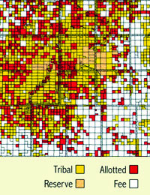

## Escheat

* The reversion of the property of a deceased person to the government when there are no legal heirs.

## Fee Simple (Fee Land)

* Land ownership status in which the owner holds title to and control of the property. The owner may make decisions about land use or sell the land without government oversight.

## Fee-to-Trust Conversion

* When original allotted trust lands that were transferred to fee land status are returned to trust status. Tribes or individual Indians can initiate the process on fee lands they already own or lands they acquire. In general, this conversion can take as much as two years.

## Forced Fee Patents

* A trust-to-fee conversion without the request, consent, or knowledge of the landowner. Forced fee patents led to the loss of many land parcels through tax foreclosure sales.

## Fractionated Ownership (Fractionation)

* When a trust parcel is owned by more than one owner as undivided interests. Fractionated ownership results from ownership interests being divided again and again when an owner of the interest dies without a will providing for the distribution of the asset. Trust parcels with fractionated ownership often have hundreds, sometimes thousands, of owners. By law, a majority of owners must agree to a particular use of the land, making it difficult for any one of the owners to use the land (i.e. for farming, building a home or starting a business).

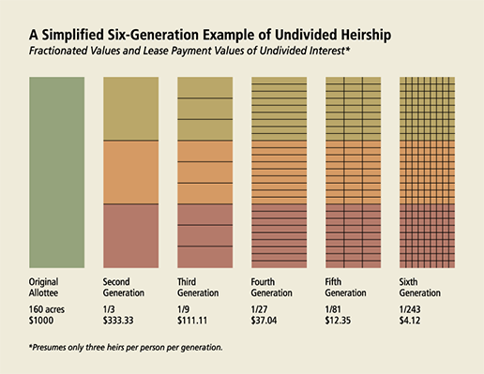

## Indian Land Tenure

* The terms and conditions by which Indians hold land.

Indian Landowner

* Any tribe or individual Indian who owns an interest in Indian land in trust or restricted status.

## Individual Indian Money Account (IIM Account)

* Fund account administered by the Department of the Interior. Funds deposited into these accounts come from a number of sources, including land-related income from leases, timber harvest and mineral extraction on Indian land. In general, each Indian person with an undivided interest in trust land holds an IIM Account.

## Interest

* When used with respect to Indian land, an interest is an ownership right to the surface estate of Indian land that is unlimited or uncertain in duration. This includes life estates.

## Intestate

* Leaving no legally valid will.

## Joint Tenancy with the Right of Survivorship

* When land is owned with other parties as joint tenants and the right to the land lasts as long as each joint tenant is alive. As each joint tenant dies, the surviving joint tenants receive the share of the deceased joint tenant. Eventually, the last surviving joint tenant owns the entire interest in the land, and only that person can decide who gets the land after that remaining tenant dies.

## Land Rights

* Although we often speak of people “owning land,” in an American legal context it is more correct to say that people have obtained rights to inhabit and use land. American jurisprudence has slowly evolved to consider property as not the physical object but as a “bundle of rights” composed as legal relationships such as the “right to sell” or “right to devise.” Usually, these rights or legal relations have economic or sale value if they are allowed to be transferred. In American law, the rights to inhabit and use land can be gained by conquest, decree, sale, lease, easement, escheat, patent, or by other agreement. The rights held by one individual may be conveyed to one or more other individuals. The rights to the surface of the earth may be held by different individuals than those who have the rights to the space above (super-surface) and the material below the surface (subsurface) of the earth. Furthermore, the rights to the surface, subsurface, and super-surface may each be shared by many individuals. Most rights are conveyed by a written instrument which evidences a transaction in which any interest in land is created, alienated, mortgaged, or assigned. However, it is important to note that, while different Native people may treat and use land very differently, the concept that people inhabit but do not own the land is still a part of Native American culture. The following quote from the Kickapoo prophet Kanekuk is a good example of this philosophy: “Some of our chiefs make the claim that the land belongs to us. It is not what the Great Spirit told me. He told me that the land belongs to him, that no people own the land…”

## Life Estate

* The right to live on, use, and take income from land during a person’s lifetime.

## Off-Reservation Trust Land

* Land outside the boundaries of a reservation that is protected by the federal government for Indian use. For example, these pieces of land could be religious sites or pieces allotted to individuals out of the public domain.

## Ownership in Severalty

* Rights to land that are owned by one individual.

## Patents-in-Fee

* The “patent” is the title deed by which the federal government conveys or transfers land to people. “In fee” refers to the fee simple ownership in land. The term “patent-in-fee” describes the title document issued by the U.S. Federal Government to terminate the trust created by the trust patent issued to the allottee. The patent-in-fee operates to vest fee simple ownership in an allottee or their heirs.

## Probate

* The process by which property is transferred from a deceased property owner to his or her heirs and/or beneficiaries. Under the General Allotment Act, a tribe’s traditional rules of descent and property transfer were replaced by the probate laws of the territory or state in which the tribal member resided or where the property was located. This is still the case when an Indian landowner dies without having written a will or when there is no tribal probate code. The Office of Hearings and Appeals (OHA) is responsible for the probate of trust property owned by deceased Native Americans and examines federal law, federal regulations, tribal law, and state law to determine the heirs and/or beneficiaries, the validity of wills, and the validity of claims.

## Remainder Interest

* If a person owns a remainder interest in land, his or her right to the land begins when the person owning the life estate in the land dies. If an Indian has the remainder interest, the land stays in trust. To prevent Indian lands from passing out of trust status, non-Indian heirs will only receive a life estate in Indian lands. Because a non-Indian heir owns less than the full interest, a “remainder interest” is created, and this remainder interest must go to an Indian. If there are no such heirs, the remainder may be purchased by any Indian co-owner of the parcel. If no offer is made to purchase the parcel, the remainder interest passes to the tribe. The rules are applicable to both testate and intestate Indian estates.

## Restricted Fee Land

* The ownership is the same as fee simple land, but there are specific government-imposed restrictions on use and/or disposition.

## Tenancy in Common

* The most common form of ownership of rights to land held in trust for Native Americans. Tenants in common have unity of possession, which means that every owner has an equal right with their co-owners to the land as long as they live. A tenant in common has an undivided interest in the whole property as if they were the sole owner, and can transfer their interest by gift, sale or will. A tenant in common can also decide who will own their interest when they pass away.

## Testamentary Disposition

* Property bequeathed or set out in a will.

## Testate

* Having made a legally valid will.

## Testate Succession

* The transfer of property according to a legally valid will.

## Title Status Report (TSR)

* Also referred to as an Interest Report Simple or Interest Report, a TSR takes the place of a title commitment for land that is held in trust. The TSR is a necessary precursor to issuing a mortgage for a property on trust land.

## Tribally-Owned Land

* Land that is owned by a group of Indians recognized by the federal government as an Indian tribe.

## Trust Land

* Land owned either by an individual Indian or a tribe, the title to which is held in trust by the federal government. Most trust land is within reservation boundaries, but trust land can also be off-reservation, or outside the boundaries of an Indian reservation.

## Trust Patent

* Individual Indian allottees were issued documents called “trust patents” to verify that their land was held in trust by the government.

## Trust-to-Fee Conversion

* The conversion of lands held in trust by the U.S. Federal Government to fee simple status. With the passage of the Burke Act of 1906, Indian lands held in trust were converted to fee status if the Secretary of the Interior determined that the Indian landowner was competent. Today, trust lands can be converted to fee status in 30 days. Only individual Indian landowners can request a trust-to-fee conversion.

## Undivided Interest

* A share of the ownership interest in a parcel of trust land. The number of interests grows with the division among heirs of these interests according to federal or tribal

## Usufruct

* The legal right to use or profit from another’s property.

Source: <http://iltf.org/resources/other-resources/>

June 10, 2017