The Dawes Act, 1887
Congressman Henry Dawes of Massachusetts sponsored a landmark piece of legislation, the General Allotment Act (The Dawes Severalty Act) in 1887. It was designed to encourage the breakup of the tribes and promote the assimilation of Indians into American society. It would be the major Indian policy until the 1930s. Dawes’ goal was to create independent farmers out of Indians — give them land and the tools for citizenship.
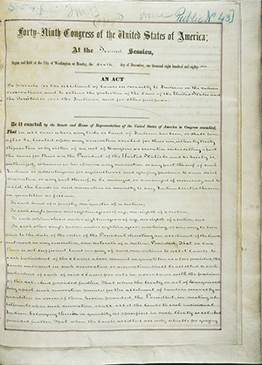
The Dawes Act, 1887. Courtesy National Archives and Records Administration
Reactions to Senator Dawes’ Act were quite varied. Alice Fletcher, an Eastern woman who was a leader of a group called "Friends of the Indians," was one of the architects of the new law.
"The Indian may now become a free man; free from the thralldom of the tribe; freed from the domination of the reservation system; free to enter into the body of our citizens. This bill may therefore be considered as the Magna Carta of the Indians of our country."
— Alice Fletcher
A Nez Perce Indian expressed a quite different reaction:
"We do not want our land cut up in little pieces. . . . A groan of assent ran along the dark line of Sphinxes."
Congressman Henry Dawes expressed some rather startling views in the following statement.
"... expressed his faith in the civilizing power of private property with the claim that to be civilized was to ‘wear civilized clothes ... cultivate the ground, live in houses, ride in Studebaker wagons, send children to school, drink whiskey [and] own property."
While Senator Dawes may have been well meaning in his intentions, the results were less than satisfactory for the Indians. It provided for each head of an Indian family to be given 160 acres of farmland or 320 acres of grazing land. The remaining tribal lands were to be declared "surplus" and opened up for whites. Tribal ownership, and tribes themselves, were simply to disappear. The story would be much the same across much of the West. Before the Dawes Act, some 150 million acres remained in Indian hands. Within twenty years, two-thirds of their land was gone. The reservation system was nearly destroyed.
Standing Bear, Tibbles, and other who participated in the lecture to the East to gain support for the Ponca cause specifically, and the Indian cause in general, did not foresee the problems that legislation like the Dawes Act would create. Land allotted to individual Indians was soon controlled by non-Indians. Indians lost much of their land and received very inadequate payment for the land they gave up. Indians, who received compensation for giving up their land, also quickly spent the money. They were unused to managing money. Few contemporary historians would judge the allotment policy of acts like the Dawes Act, successful.
Source: Adapted from NebraskaStudies.org http://nebraskastudies.org/0600/frameset_reset.html?http://nebraskastudies.org/0600/stories/0601_0200.html
June 30, 2017

