Superintendent of Public Instruction
Food Distribution System Replacement Project
Background and Analysis

Version 1.0 – September 21, 2021

Document Revision History
Modifications to this document are documented in chart below. Note that the Project Sponsor and the Project Manager must sign off any changes to the requirements document.
Version | Date | Author/Editor | Comments
1.0 | 09/21/2021 | Bethany Kirk | Initial draft for review.

Glossary of Terms and Acronyms
To provide clarity, terms and acronyms used in this document are defined as follows:

Term / Abbreviation | Definition
CNP | Child Nutrition Program team at OSPI
Diversion | Diversion processing is the process of sending selected bulk raw USDA foods directly to selected processors to process into finished end-products
DoD | Department of Defense Fresh Fruit and Vegetable Program
Entitlement Allocation | Federal funding obligations to eligible recipients based on specific criteria for Sponsors, as determined by the USDA
Fiscal | The fiscal team at OSPI, responsible for processing payments
IEDS | Inland Empire Distribution Systems used for 3rd party warehouse logistics.
Notifications and Alerts | Any message, including email or on-screen messages such as a pop-up, meant to inform user of the results of validation or a process, system status, etc.
NSLP | National School Lunch Program (NSLP), open from approximately August to June.
OSPI | Office of the Superintendent of Public Instruction, Washington State's department of education
Pilot | Unprocessed Fruits & Vegetable Pilot Food Program
Processor | Entity that processes commodities into end-products
SFSP | Summer Food Service Program (SFSP) - open from approximately March to June.
USDA | United States Department of Agriculture Food Program
User | A user with system access. Usually, the user is either from OSPI staff or from the staff of an educational entity, although external users (e.g., warehouse) are anticipated.
Warehouse | One, or more, of four warehouses that receive and store food products, and coordinate delivery to Sponsors. There are currently two warehouses (one frozen, one dry) on the East side and two (one frozen, one dry) on the West side of the state.
WBSCM USDA | Web Based Supply Chain Management system for commodity acquisition, distribution, and tracking
WCODES | Refers to products received from processors
Workflow | The sequence of process steps through which a piece of work passes from initiation to completion. The sequence may require participation by different users, to be completed.
Workstream | Groups of business processes. For the purpose of this document, used interchangeably with Business Process

Table of Contents

1 Purpose 6
2 Overview 7
2.1 Background 7
2.2 Executive Summary 7
2.3 Scope of Requirements 8
3 Business Processes and Pain Points 10
3.1 High Level Workflow Diagrams and Pain Points 10
3.1.1 Prepare for New School Year 10
3.1.2 Manage and Place Monthly Orders 13
3.1.3 Manage Deliveries 18
3.1.4 Invoicing and Payments 21
3.2 External Stakeholders – Pain Points 24

Purpose
The purpose of this document is to provide additional background and context to the documented functional and non-functional requirements (see Attachment B). To assist in placing requirements into greater context, this document includes high level as-is and to-be workflow diagrams, as well as documented pain points for the following workstreams: preparing for a new school year, managing, and placing monthly orders, managing monthly deliveries, and invoices and payments.

Overview

Background
Child Nutrition Services administers the USDA Food Distribution Program. Functions of operating this program include ordering commodities from USDA, contracting and management of the processing of commodities into end-products, distribution entitlement to sponsors (School districts and other sponsors operating Child Nutrition programs), processing and arranging shipping of commodities to sponsors, invoicing and processing payments. CNS currently uses the electronic system “CNP 2000.” This system was purchased from and is currently hosted by Dynamic Internet Solutions.
Problems that have been identified include:
- Outdated System: The system was purchased in 2008. The company is now multiple versions past the version that we operate. Upgrades or enhancements to the system are not available.
- User Interface: Sponsors struggle to use the system. USDA regulations mandate that the state agency and sponsors utilize entitlement and USDA foods to the maximum extent possible. CNP 2000 is not intuitive, it’s difficult for sponsors to adjust orders, see history of orders, generate reports and view past invoices and credits. Additionally, there are Sponsor tasks such as receipt of delivery, notification of damaged products that are done outside the system.
- System lacks functions: There are many functions that the system is not able to do, therefore staff perform multiple functions and maintain tracking logs outside of the system.

Executive Summary
The CNP 2000 system provides a means by which OSPI program staff administers the USDA food program. Other food programs that CNP 2000 system features support include Processor/WCODES, DoD, Diversion, and Pilot.
OSPI users manage annual orders, inventory, monthly orders and delivery, and invoicing and payments through this system. They allocate entitlement dollars to Sponsors who use the entitlement credits to order products from the food programs listed above. Additionally, OSPI’s fiscal unit has access to the system for the purpose of processing payments.
Sponsors use the system to submit annual pre-order surveys (monthly food orders for the entire upcoming school year) and to confirm monthly orders.
Warehouse users primarily use the system for confirming information (e.g., delivery contact and location). They also have access to reports.

OSPI has developed a large backlog of desired enhancements, but they are not able to modify the existing system. There is no integration between the current system and other internal systems (WINS) and external systems (suppliers’ ordering systems, warehouse/inventory system, and financial systems) which results in manual and redundant data entry. Additionally, there is no ability to automate workflow to improve efficiencies and communication and to reduce risk of error.
Further the existing system was not designed to accommodate other, non-USDA food programs such as Department of Defense Fresh Fruits and Vegetables, Processor/WCODES, Diversion, and Pilot programs. OSPI has established a series of workarounds to administer those programs.
Over one hundred seventy (170) requirements were identified through a series of interviews and analysis of existing processes and documentation. As-is process diagrams were documented, then reviewed for accuracy. During review of as-is workflows, pain points were also discussed. Analysis was then conducted of both the as-is processes and associated pain points. To-be process workflows were then documented and proposed. Requirements – in the form of user stories – were identified and documented during walk-throughs of the to-be process diagrams. Additionally, through reviews with the business sponsor and subject matter experts, each requirement was prioritized as either being mandatory (high), essential (medium), or desired (low).
OSPI identified six (6) key features desired for acceptance of any solution.
- Order management
- Inventory management
- Invoicing and payment processing
- Reports and analytics
- Automated workflow management
- System interfaces
To assist in the next steps in the use of system requirements in the selection of a system replacement, this document describes key requirements in the context of high-level business processes.

Scope of Requirements
The scope of the Food Distribution Replacement Project includes key functionality provided by the current CNP 2000 system – order management, inventory management, invoicing and payments processing, and reports and analytics – and additional requirements to support desired improvements, including:
- Improved financial management of federal entitlement dollars through improved pricing strategies and improved inventory management
- Improved internal controls
- Improved Sponsor experience and management of FDP entitlement dollars
- Improved accuracy and efficiency through automated workflow
- Implementation of system interfaces with internal and external systems to automate the exchange of data
Requirements were collected from stakeholders in the following groups:
- OSPI program staff – responsible for administering the food distribution program
- OSPI fiscal staff – responsible for processing payments
- Sponsors – participants in food distribution programs administered by OSPI
- Warehouse staff – responsible for tracking inventory in four warehouses throughout the state

Business Processes and Pain Points

High Level Workflow Diagrams and Pain Points
High level as-is and to-be workflow diagrams and identified pain points are provided here to assist in providing context for documented requirements (see Attachment B). Additionally, simple descriptions of the processes and key tasks for each user group are included.

Prepare for New School Year
Summary: The system must provide a means by which OSPI Food Distribution Program staff can prepare for the upcoming school year, and Sponsors can submit their annual pre-orders. Key tasks include:
OSPI
- Roll over prior year data to new school year
- Update product and pricing information
- Approve new participants/Sponsors
- Assign entitlement allocation to Sponsors
- Update monthly product availability
- Create pre-order form/survey
- Input consolidated monthly orders in supplier’s order system
Sponsors
- Submit pre-order survey

As-Is Process Diagram

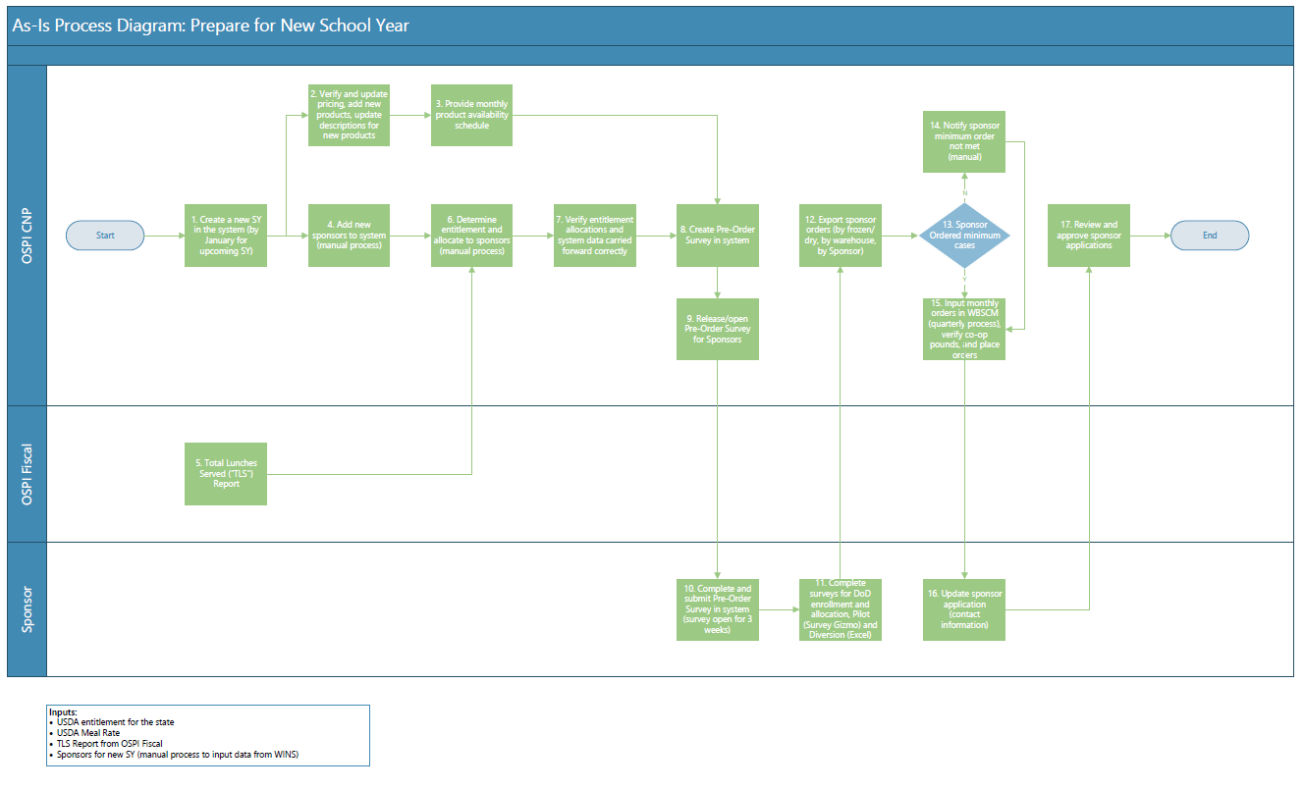

To-Be Process Diagram
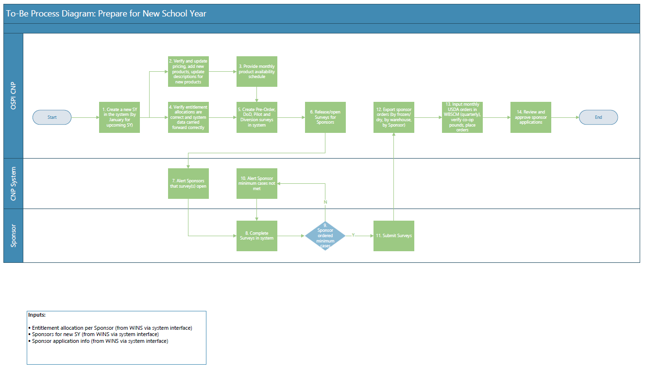

Pain Points
OSPI identified several pain points – listed below – for this business process. These were addressed in both the to-be process diagram and requirements (see Attachment B).
- WINS is not currently integrated with/in CNPWeb. Manual processes to extract data from WINS and use it in/for CNPWeb. E.g., contact info, names of sponsors, new sponsors, Active/Inactive Sponsor indicator, calendar info (sponsor closure dates - may require updates to WINS), Total Lunches Served (“TLS”).
- Additionally, there is currently information in WINS that could be leveraged to improve process efficiency, e.g., during July-Sept after school year has started, renewal agreements in WINS are being entered. There is a question regarding intent to participate in USDA foods program. There is currently no way to gather this info and distribute to CNP staff. It would be helpful if this information could be integrated with, and displayed to OSPI CNP users, in the CNP system.
- Minimum cases per product per delivery month (15-20 frozen, 15-20 dry per warehouse) is noted on the Pre-Order Survey, but the system does not alert users when they have not met minimum when saving or submitting their survey.
- DoD enrollment and allocation, Pilot surveys require a third-party system (Survey Gizmo) and are not configured and/or executed in the system. Diversion survey is also not available in the CNP system and is done via excel spreadsheets. If system could accommodate all these that would be ideal.
- Currently, Sponsors are only able to verify program contact in the system. No current ability to verify delivery contact. Ability to display delivery contact to Sponsor for verification would prevent issues later on.

Manage and Place Monthly Orders
Summary: The system must provide a means by which OSPI Food Distribution Program staff can manage and update available inventory and Sponsors can confirm monthly orders. Key tasks include:
OSPI
- Update inventory as received from suppliers
- Fill product inventory (make it available for Sponsors’ monthly orders)
- Open system for monthly orders
- Manage surplus product
- Verify Sponsors ordered minimum number of cases
- Close system for monthly orders
Sponsors
- Review and confirm monthly orders
- Order product from surplus

As-Is Process Diagram – USDA
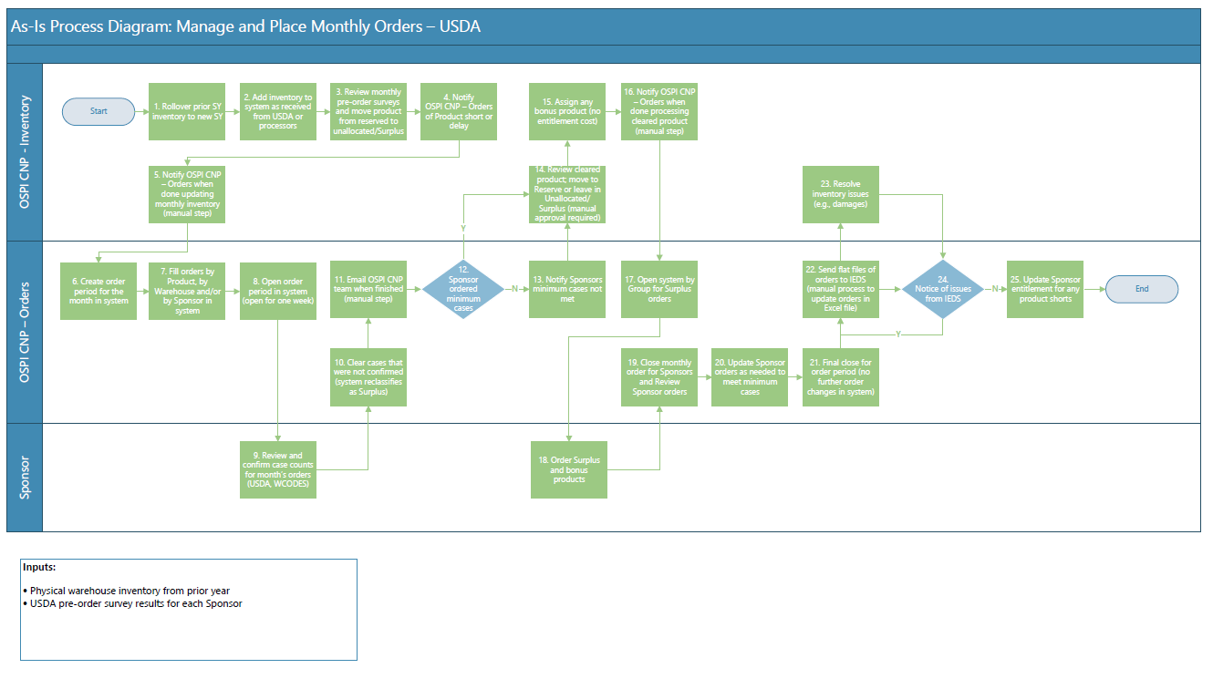
As-Is Process Diagram – DoD and Diversion
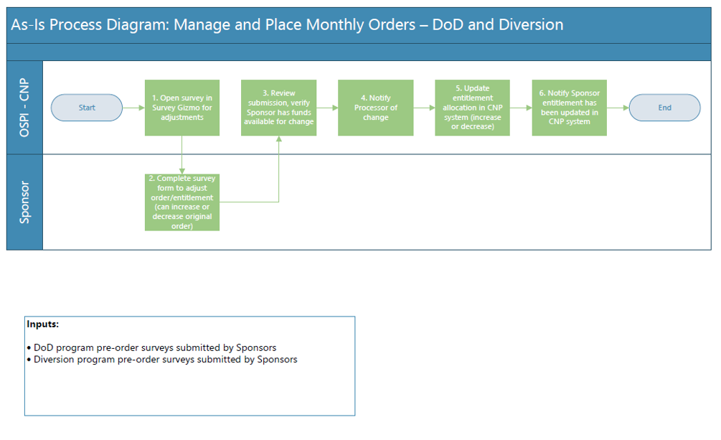

To-Be Process Diagram – USDA
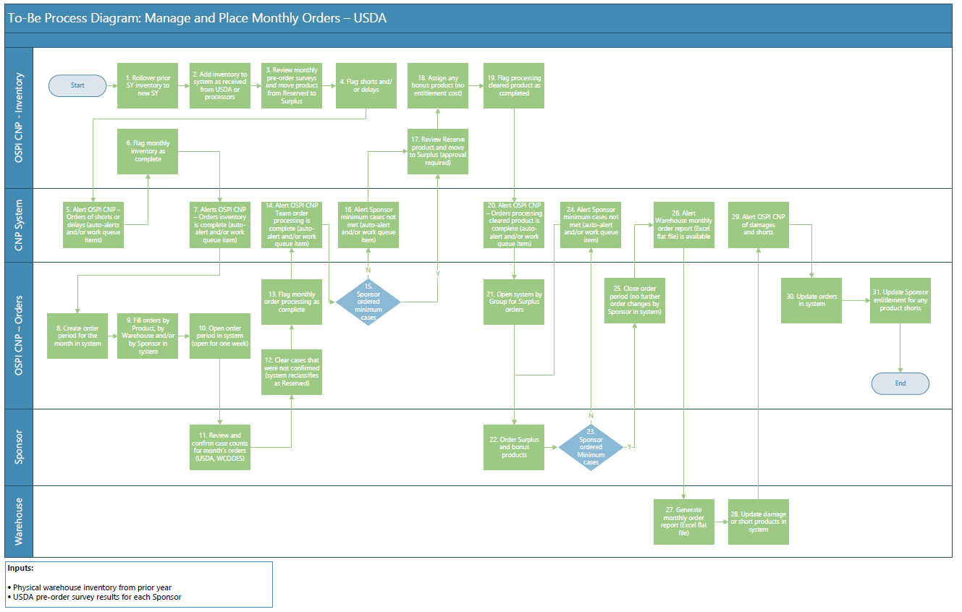
To-Be Process Diagram – DoD and Diversion
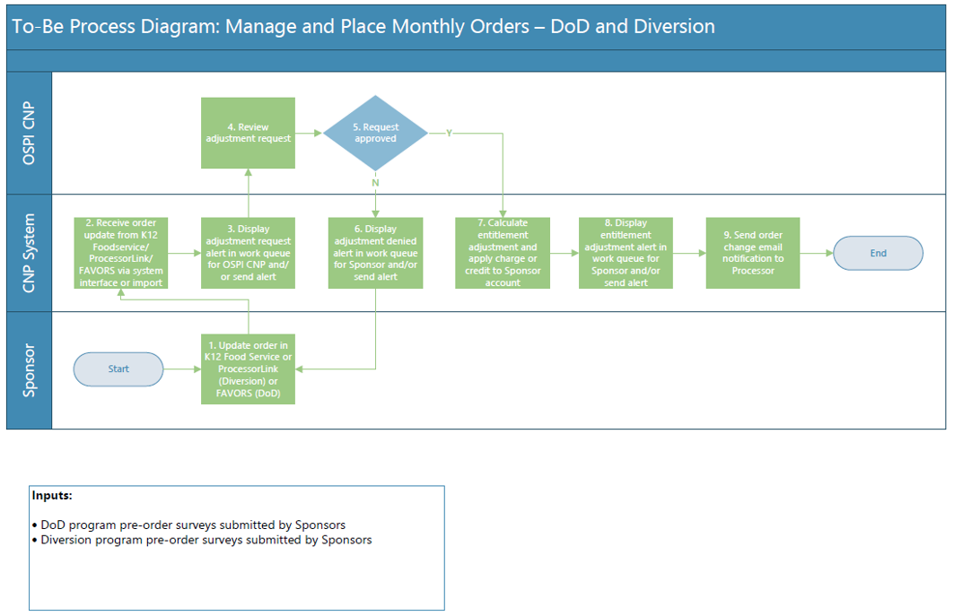

Pain Points
OSPI identified several pain points – listed below – for this business process. These were addressed in both the to-be process diagram and requirements (see Attachment B).
- Currently must send email when monthly inventory complete, auto-notify would be nice
- When Sponsors confirm monthly orders, they are not currently notified if not met minimums
- Currently, default is that when products are cleared, they are automatically assigned to Surplus status. Prefer that all cleared products automatically are assigned to 'Reserved' category/status instead. Then can be moved to Surplus if desired.
- Just need Reserved or Available, currently have Reserved, Unallocated and Surplus, but don't appear to need both Unallocated and Surplus because they are both available to Sponsor
- No current ability to revise orders after 'final' close when IEDS notifies of issues; and must update Excel files manually. Ability for admin to revise orders after final close would be helpful.
- Ability to track and view history of system changes, including changes to sponsor application information, order/inventory information and product/pricing information would be helpful.

Manage Deliveries
Summary: The system must provide a means by which OSPI Food Distribution Program staff can manage and track monthly product deliveries to Sponsors.
OSPI
- Track deliveries (from suppliers to warehouses)
- Monitor and update inventory (overs, shorts, damages)
- Adjust orders for overs, shorts, damages
Sponsors
- Receive deliveries
- Report overs, shorts, damages
Warehouse
- Receipt product (daily) as received from suppliers
- Report overs/shorts/damages
- Coordinate delivery from warehouse to Sponsors

As-Is Process Diagram
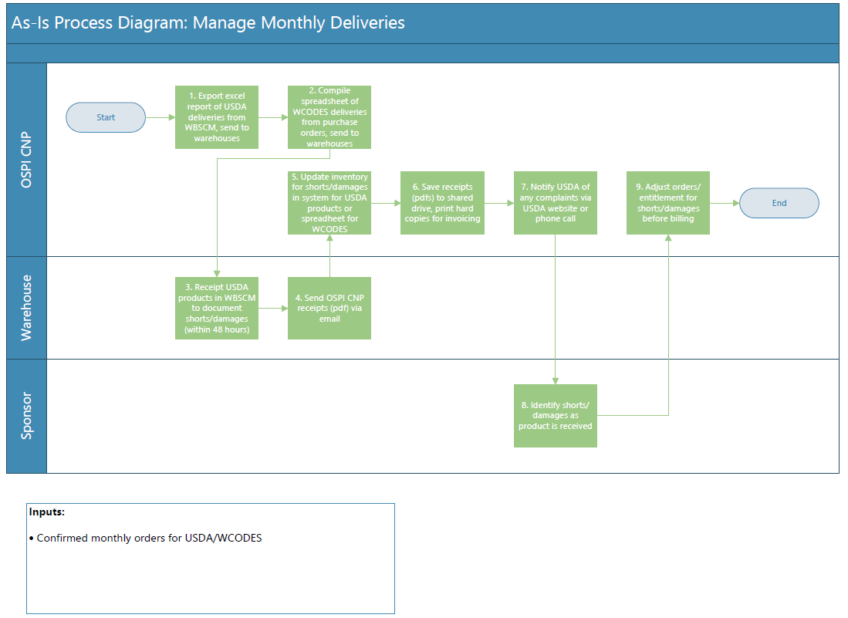
To-Be Process Diagram
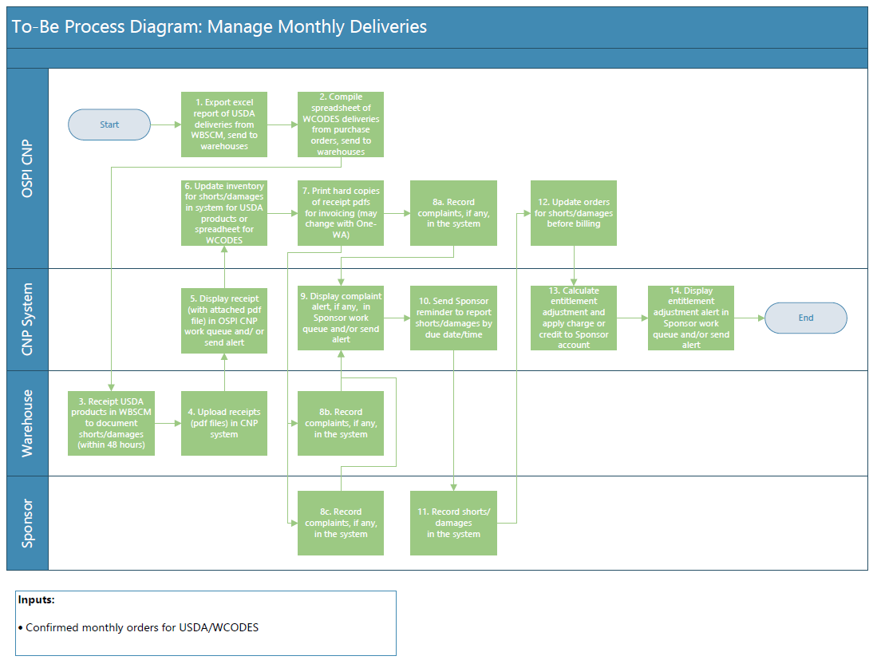

Pain Points
OSPI identified several pain points – listed below – for this business process. These were addressed in both the to-be process diagram and requirements (see Attachment B).
- Currently difficult to interface with WBSCM because there are two warehouses. No plan for current system to interface with that system. Any ability to import files into new system would be nice to have.
- Ideally, there would be an ability for IEDS/WH contractor to note shorts/damaged products in the system
- When shortages/overages aren't reported at the Sponsor, it really causes issues with inventory. Cumulative impact to state inventory if things aren't reported. There is an option for Sponsors to report these in the system, but they rarely do so.
- System does not send reminder to sponsors to report any order discrepancies by a certain date/time. There is a known due date for all orders to be delivered to sponsors. This could be a reminder date.
- Ideally, would track any discrepancies/updates to orders for Diversion, DoD and Pilot in the system for these programs in order to update entitlement balance for accounting purposes

Invoicing and Payments
Summary: The system must provide a means by which OSPI Food Distribution Program staff can manage and process invoices and payments.
OSPI
- Process invoices received from suppliers for payment
- Issue invoices to Sponsors for delivered product
- Process payments from Sponsors to OSPI (Fiscal)
- Process payments from OSPI to suppliers (Fiscal)
Sponsors
- Pay monthly invoices

As-Is Process Diagram
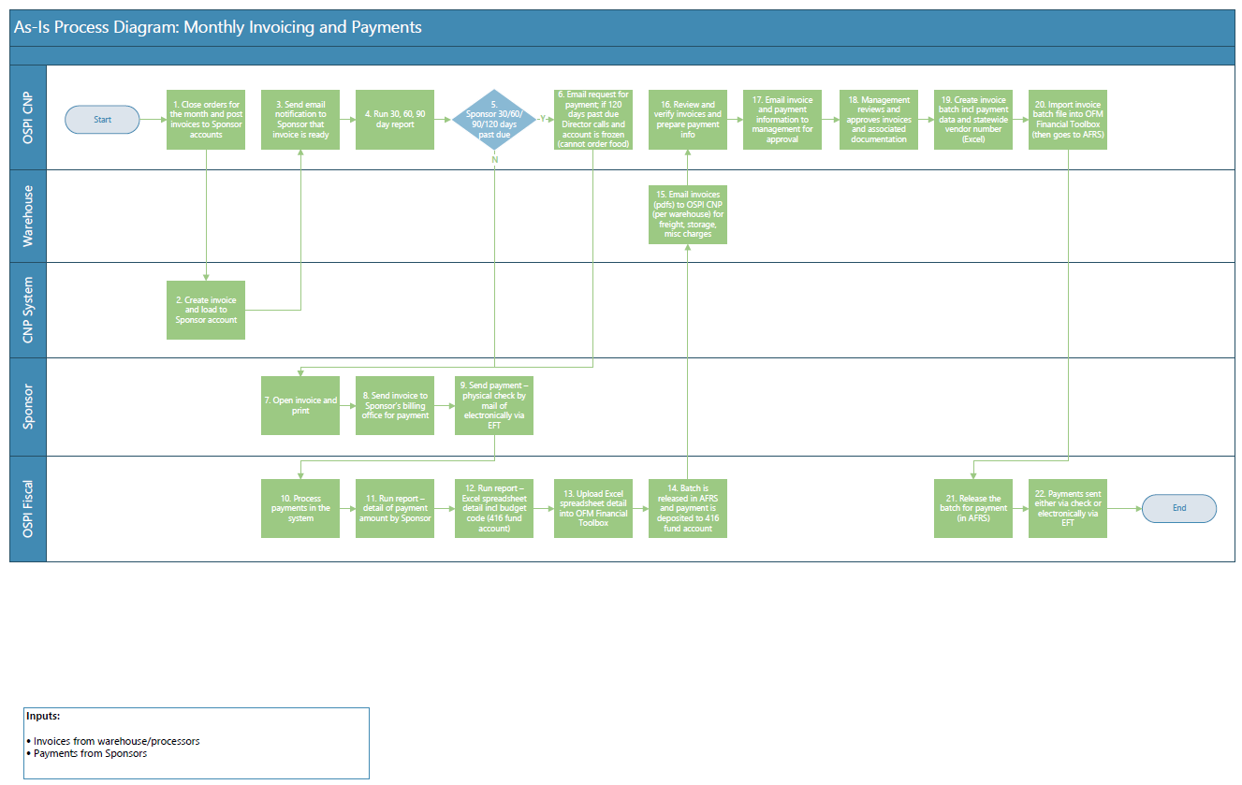

To-Be Process Diagram
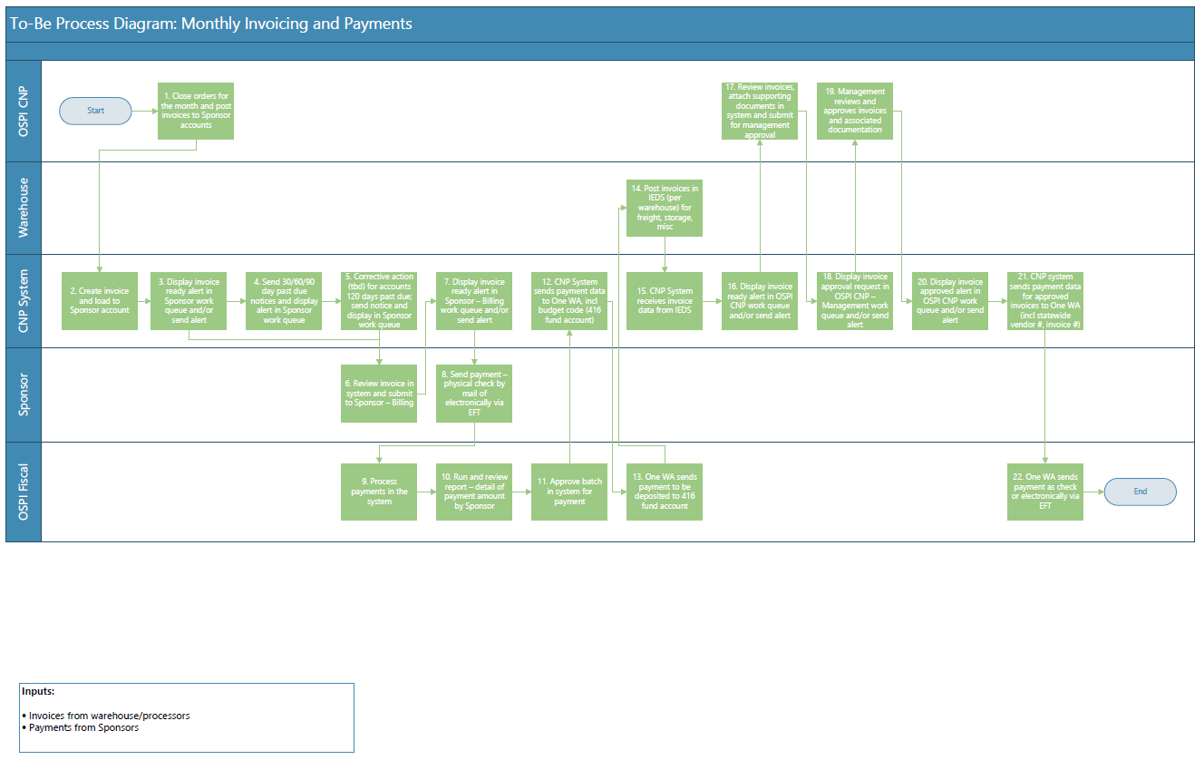
Pain Points
OSPI identified several pain points – listed below – for this business process. These were addressed in both the to-be process diagram and requirements (see Attachment B).
- No interface with financial system. The goal is to interface with One WA. This is still being envisioned. Currently, that effort is in the design phase and there is limited knowledge how it will be implemented.
- Warehouse user ability to post invoices in system, by Sponsor, including ability to save pdf files of supporting documents in the system
- Re: OSPI management approval of WH/processor invoices – work queue, auto-alerts would be helpful. Would depend on One WA, as this is all done outside CNP
- Manually post cash credit to Sponsor account if anything isn't correct, CNP accounting updates sponsor accounts manually e.g., credits, if they pay too much or OSPI owes them, CNP accounting manually issues credit in the system. This is hard cash, vs entitlement (i.e., ‘monopoly money’). CNP accounting must then follow up via email to reconcile these transactions.
- Ability to credit sponsor accounts. Once process of invoicing is over, whether OSPI is covering the cost or sponsor is through credits.
- If system could automatically generate emails at 30-, 60-, 90-days and note accounts, display alerts in work queue
- Ability to flag account in CNP system as not paid and implement corrective action (e.g., stop shipments)
- Need some kind of stop-order feature when they are no longer allowed to order, e.g., Sponsor is in Stop Pay status in WINS, CNP system needs to display that as well. When on stop pay, then do not ship foods to them. Some way to integrate Stop Pay flag from WINS communicated to new system would be nice.
- Display in work queue that Sponsors are 30-60-90-120 past due.

External Stakeholders – Pain Points
External stakeholders were consulted to gather their pain points with the program and existing system. Sessions were conducted with Sponsors and warehouse users and the pain points listed below were identified. These pain points were then analyzed, and requirements were established and documented to address the identified issues.
Sponsors
- Printing reports doesn't work well in Google Chrome, however, once you get reports they are sufficient
- Damaged products are an issue, i.e., when products are damaged in truck (e.g., smashed fruit cups)
- Not sure whether they're credited for damaged products
- Being able to sort items on orders and reports alphabetically (instead of by item number) would be helpful
- When submitting an order (e.g., for surplus), if some items are not available, the entire order is not saved. Therefore, user must resubmit order for all items that are available.
Warehouse
- Currently, main issue is with delivery addresses, out of date, or the contact is no longer there (retired, left, etc.)
- Another issue is with unexpected school/site closures
- Would like an alert when Sponsors report overs, shorts or damages
- Ensure that OSPI is updating inventory for daily receipts
- Do not allow Sponsors to order product if not receipted by warehouse
- Flat file of orders/deliveries should only include product that has been receipted by warehouse
- Suggest process change: OSPI should run report of discrepancies between what is receipted/on-site at warehouse vs what Sponsors ordered before they generate the flat file. Then, they should update orders if needed to reconcile with product availability. Then generate the flat file because the current information is not accurate.
- In the past, there have been issues with Sponsors reporting shorts, but they actually received all they confirmed. Though, this was less than initial, pre-order amount
- Suggest system computing short credit based on number confirmed in monthly order vs what was delivered

